**ARESUME: A WEB-BASED RESUME GENERATOR WITH AUGMENTED REALITY FEATURES**

**MARY CHEW JIA YI**

**A project report submitted in partial**

**fulfilment of the requirements for the award of**

**Bachelor of Software Engineering with Honours**

**University Malaysia of Computer Science and Engineering (UNIMY)**

**September 2019**

The copyright of this thesis belongs to the author under the terms of the copyright Act 1987 as qualified by the Intellectual Property Policy of University Malaysia of Computer Science and Engineering (UNIMY). Due acknowledgement shall always be made of the use of any material contained in, or derived from, this thesis.

© 2019, Mary Chew Jia Yi. All rights reserved.

DECLARATION

I hereby declare that this project report is based on my original work except for citations and quotations which have been duly acknowledged. I also declare that it has not been previously and concurrently submitted for any other degree or award at University Malaysia of Computer Science and Engineering (UNIMY) or other institutions.

|  |  |  |
| --- | --- | --- |
| Signature | : |  |
| Name | : | Mary Chew Jia Yi |
| ID No. | : | B02170010 |
| Date | : |  |

APPROVAL FOR SUBMISSION

I certify that this project report entitled **“ARESUME: A WEB-BASED RESUME GENERATOR WITH AUGMENTED REALITY FEATURES”** was prepared by **MARY CHEW JIA YI** has met the required standard for submission in partial fulfilment of the requirements for the award of Bachelor of Software Engineering at University Malaysia of Computer Science and Engineering (UNIMY).

Approved by,

|  |  |  |
| --- | --- | --- |
| Signature | : |  |
| Supervisor | : | Mdm Erlida binti Ruslan |
| Date | : |  |

Specially dedicated to

my beloved family.

ACKNOWLEDGEMENTS

I would like to thank everyone who had contributed to the successful completion of this project. I would like to express my gratitude to my research supervisor, Mdm Erlida for her invaluable advice, guidance and her enormous patience throughout the development of the research. I would like to thank my co-supervisor, Dr. Ong Huey Fang for spending her free time to guide my project and keep track of my progress of this project.

In addition, I would also like to express my gratitude to my loving family who have guided and helped me towards the completion of the project. Especially my sister, Ruth Chew who have given me moral support in completing this project.

Besides, I would like to thank my friends Quek, Tyze Qian, Joseph, Xavier, Brandon, Sheng Kai, Matyn, Edward for cheerleading, supporting and helping and guiding me in this project. And also to those who have not been mentioned, thank you for your support as well.

**ARESUME: A WEB-BASED RESUME GENERATOR WITH AUGMENTED REALITY FEATURES**

ABSTRACT

Resume is an important tool for job seekers when it comes to job hunting. With a professional resume, it might help them to secure a job. This project is intended to develop a web-based resume generator alongside with augmented reality features, known as AResume. The web-based application built is a typical resume generator that generates resume with augmented medias. It is built for job applicants who have difficulty in creating a professional resume from scratch, as well as trying to attempt “one-size-fits-all” approach, which fits all information in a resume. A web augmented reality (AR) will be developed over mobile AR because of its lightweight approach, cross-platform support and no installation is necessary. The methodology of this project is Rapid Application Development, which it rapids the development process and allows bugs fixing to be done in parallel with the development. In this project, PHP, jQuery and Bootstrap are used in web development. In addition to that, AR.js and A-Frame are the main web AR frameworks employed in this project as they are easy to be used and can enrich the experience of augmented reality among job applicants and hiring managers. The generated resume is embedded with QR code and AR markers. The QR code is scanned with QR code scanner using smartphone and it directs users to the AR scanner website. Users are able to move the scanner from marker to marker to view different contents (video, photo and documents). In testing phase, system testing and user acceptance testing were carried out to ensure the quality of the system. Hence, by using AResume, not only it will enable job applicants to create resume, upload digital medias as augmented features and scan the resume by using web browser, but also provides better user experience for hiring managers when reviewing resumes.

TABLE OF CONTENTS

DECLARATION ii

APPROVAL FOR SUBMISSION iii

ACKNOWLEDGEMENTS v

ABSTRACT vi

TABLE OF CONTENTS vii

LIST OF TABLES x

LIST OF FIGURES xi

LIST OF SYMBOLS / ABBREVIATIONS xvi

LIST OF APPENDICES xvi

**CHAPTER TITLE PAGE**

CHAPTER 1 17

1 INTRODUCTION 17

1.1 Background 17

1.2 Problem Statement 19

1.3 Aim and Objectives 19

1.4 Scope 20

1.5 Significance of the Project/Research 20

1.6 Organization of Thesis 21

CHAPTER 2 22

2 LITERATURE REVIEW 22

2.1 Introduction 22

2.2 Resume 22

2.3 Ways to Build a Resume 27

2.4 Augmented Reality 29

2.5 Comparison Between Similar Existing Applications 35

2.6 Summary 42

CHAPTER 3 44

3 METHODOLOGY 44

3.1 Introduction 44

3.2 Rapid Application Development 44

3.3 Project Development 45

3.4 Development Technology 46

3.5 Summary 52

CHAPTER 4 53

4 ANALYSIS AND DESIGN 53

4.1 Introduction 53

4.2 Survey Analysis 53

4.3 User Requirements 58

4.4 Sequence Diagram 61

4.5 Database Design 65

4.6 Component Diagram of AResume 66

4.7 Summary 67

CHAPTER 5 68

5 IMPLEMENTATION AND DISCUSSION 68

5.1 Introduction 68

5.2 Graphical User Interface 68

5.3 Libraries and Source Code 81

5.4 Testing 88

5.5 Observations 95

5.6 Summary 95

CHAPTER 6 96

6 CONCLUSION AND RECOMMENDATION 96

6.1 Conclusion 96

6.2 Recommendation 96

REFERENCES 98

LIST OF TABLES

|  |  |  |
| --- | --- | --- |
| **TABLE** | **TITLE** | **PAGE** |
| 2.1 | Description of each type of resume | 23 |
| 2.2 | Description of key components of a resume | 25 |
| 2.3 | Summary of comparison between existing similar applications and proposed solution | 41 |
| 5.1 | Test case of creating resume | 88 |
| 5.2 | Test case of scanning resume | 89 |
| 5.3 | UAT scope | 90 |
| 5.4 | UAT assumptions and constraints | 90 |
| 5.5 | UAT risks | 91 |
| 5.6 | UAT entry criteria | 92 |
| 5.7 | UAT requirements-based test cases | 93 |
| 5.8 | Test results | 94 |

LIST OF FIGURES

|  |  |  |
| --- | --- | --- |
| **FIGURE** | **TITLE** | **PAGE** |
| 1.1 | A typical resume | 17 |
| 1.2 | Pokémon Go with AR technology | 18 |
| 2.1 | Differences between CV and Resume | 23 |
| 2.2 | hans.com.my | 28 |
| 2.3 | Historical evolution of AR | 29 |
| 2.4 | Computational/storage/networking complexities for the three typical implementation mechanisms | 30 |
| 2.5 | Marker-based methods | 30 |
| 2.6 | Overview of the framework for web AR with mobile edge computing (MEC) | 33 |
| 2.7 | Browsers support tables of enabling web technologies | 34 |
| 2.8 | NovoResume | 36 |
| 2.9 | Resumizer | 37 |
| 2.10 | SnapCard | 38 |
| 2.11 | YouAugment | 39 |
| 2.12 | 8th Wall | 40 |
| 2.13 | XR.+ | 41 |
| 3.1 | Rapid Application Development | 45 |
| 3.2 | The break-down phases of AResume development | 45 |
| 3.3 | Bootstrap | 47 |
| 3.4 | jQuery | 48 |
| 3.5 | PHP | 48 |
| 3.6 | MySQL | 49 |
| 3.7 | AR.js | 49 |
| 3.8 | AR.js Marker Training | 50 |
| 3.9 | Barcode and pattern markers | 50 |
| 3.10 | A-Frame | 51 |
| 3.11 | 000webhost | 52 |
| 4.1 | Percentage of respondents by gender | 54 |
| 4.2 | Percentage of respondents by age | 54 |
| 4.3 | Percentage of respondents by their current employment status | 54 |
| 4.4 | Career areas involved by respondents | 55 |
| 4.5 | Frequency in using different ways to build the resume | 55 |
| 4.6 | Names of the resources to build resume | 56 |
| 4.7 | Satisfaction gained from using the resources to build resume | 56 |
| 4.8 | Challenges faced in building resume | 57 |
| 4.9 | Importance of the contents displayed with AR | 57 |
| 4.10 | Preference for features in AResume | 58 |
| 4.11 | Importance of attributes in AResume | 58 |
| 4.12 | Use case diagram for job application | 59 |
| 4.13 | User sign up/sign in sequence diagram | 61 |
| 4.14 | Build resume sequence diagram | 62 |
| 4.15 | Manage resume sequence diagram | 63 |
| 4.16 | Scan resume sequence diagram | 64 |
| 4.17 | Database design of AResume | 65 |
| 4.18 | AResume system architecture | 66 |
| 5.1 | User sign up / sign in form | 69 |
| 5.2 | Resume dashboard | 69 |
| 5.3 | Choose a template | 70 |
| 5.4 | Profile section | 71 |
| 5.5 | Education background section | 72 |
| 5.6 | Work history section | 73 |
| 5.7 | Activities section | 74 |
| 5.8 | Award section | 75 |
| 5.9 | Resume completion success message | 76 |
| 5.10 | Online resume with generated URL | 77 |
| 5.11 | Edit resume | 78 |
| 5.12 | Delete resume | 78 |
| 5.13 | Resume in PDF | 79 |
| 5.14 | Resume in Word | 79 |
| 5.15 | The scanning process | 80 |
| 5.16 | The AR output display on smartphone | 81 |
| 5.17 | Bootstrap, Google Fonts, Font Awesome, jQuery libraries | 82 |
| 5.18 | AR.js and A-Frame libraries | 82 |
| 5.19 | Code snippet of submitting personal information | 83 |
| 5.20 | Code snippet of uploading transcript | 83 |
| 5.21 | Code snippet of uploading photo of an activity | 83 |
| 5.22 | Code snippet of uploading award certificate | 83 |
| 5.23 | Code snippet of the dashboard | 84 |
| 5.24 | Code snippet of the particular resume | 85 |
| 5.25 | Code snippet of navigating to another URL with click | 85 |
| 5.26 | Code snippet of playing the video | 86 |
| 5.27 | Code snippet of embedding video content in the marker | 86 |
| 5.28 | Code snippet of embedding document content in the marker | 87 |
| 5.29 | Code snippet of embedding photo content in the marker | 87 |

LIST OF SYMBOLS / ABBREVIATIONS

AR Augmented Reality

GUI Graphical User Interface

CV Curriculum Vitae

ATS Applicant Tracking System

CV Computer Vision

WWW World Wide Web

MEC Mobile edge computing

URL Uniform Resource Locator

AI Artificial Intelligence

SSL Secure Sockets Layer

RAD Rapid Application Development

SDLC Software Development Life Cycle

JSON JavaScript Object Notation

AWS Amazon Web Service

IaaS Infrastructure as a service

PaaS Platform as a Service

SaaS Software as a Service

VR Virtual Reality

LIST OF APPENDICES

|  |  |  |
| --- | --- | --- |
| **APPENDIX** | **TITLE** | **PAGE** |
| A | AResume Survey | 102 |
| B | Gantt Chart for FYP 1 | 107 |
| C | Gantt Chart for FYP 2 | 108 |

# 

## INTRODUCTION

### Background

A resume, or résumé is a document of several pages about a job applicant’s past employment history, education (Resume, 2019), as well as accomplishments. It often supplies an employment objective as a summary of skills, knowledge, potential contributions, voluntary work, certifications and also relevant coursework. It is useful for the job applicants to apply for posted jobs of any fields when they come across the job opening (Heathfield, 2018). Figure 1.1 below shows a typical resume.

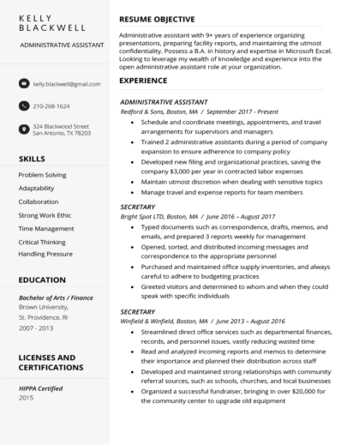

**Figure 1.1 A typical resume**

The importance of a resume is that job applicants can use it as a marketing tool to impress an employer because it outlines a job applicant’s background, skills and education that the employer will be able to see how their individual experiences can contribute to a company’s success (Resume, 2019). However, when it comes to resume screening, an employer or a recruiter takes only 8-10 seconds or even less on average to screen their resumes before considering them to be shortlisted for pre-screen interviews. Hence, it means that to make a first impression to the employer, a well-written professional resume is required (Roo, 2015).

Augmented Reality, which is abbreviated as AR, is the technology that expands our physical world by adding layers of digital information onto it. Such digital information of any forms like sounds, videos and graphics. Another definition of AR is that a view of the physical real-world environment with superimposed computer-generated images that changes the perception of reality. AR is widely used in most fields like education, tourism, furniture, healthcare, manufacturing and the like (What is Augmented Reality (AR) and How does it work, 2019). Examples of the popular AR applications are Pokémon Go, Google SkyMap and IKEA (Bonsor & Chandler, 2019). Figure 1.2 below shows a Pokemon Go mobile AR application.

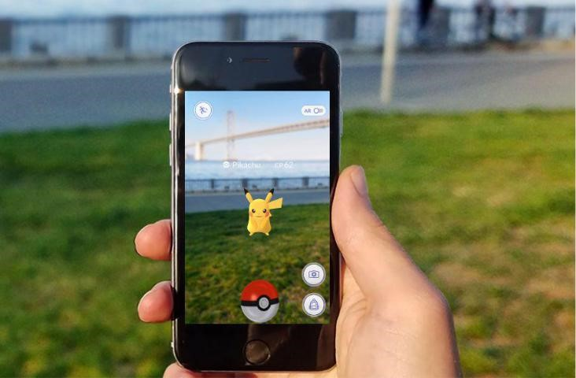

**Figure 1.2 Pokémon Go with AR technology**

### Problem Statement

Resume is an important tool to present a job applicant’s background and skillsets when it comes to job application. However, problems arise when job applicants want to write an ideal resume that stands out. One of the problems is the lack of experience of fresh graduates in building a resume. Most of them tend to make mistakes in building a resume (Mustafa, 2018) and end up producing a poorly-formatted unprofessional resume, which might not be catching employer’s eye.

Besides, job applicants who have numerous achievements and certifications would want to attempt the “one-size-fits-all” approach (Vogt, 2019) that will cause a lengthy resume. An ideal resume is about one or two pages long and consists of three key elements like working experience, measurable achievements and educational background or professional training (Mustafa, 2018). Hence, it does not allow them to attach as many achievements, certifications and other important attachments as they possibly have.

Another problem is building a resume is the tedious work being laboured in it as it includes the processes of drafting, formatting and writing (Copeland, 2019). A few ways of building a resume according to a job applicant’s preference are using existing online resume generator and also using any word processors.

### Aim and Objectives

The aim for the project is to develop a resume generator that allows job seekers to create a resume online and an AR technology as a supplement to the resume. Augmented digital elements such as videos, images and documents can be viewed in the resume through a camera of any mobile devices.

The objectives of this project are:

1. To study a comparative analysis of the existing online resume generators.
2. To develop a web-based application to generate an augmented reality resume as an interactive medium in job application and interviews.
3. To test the usability of the application with user acceptance testing.

### Scope

The target audience of this project is the job seekers. The project will be focused on the development of the resume generator website that produces an augmented reality resume.

When scanning the resume, it will display 2D computer-generated perceptual information in the form of interactive digital elements and is able to play videos and audios as well as to view documents and pictures. To use the entire application, mobile devices, camera and Internet connection are required.

In this project, Ar.js and A-Frame will be the tools to do web augmented reality which are compatible in any web browsers regardless of the operating system. Bootstrap, jQuery and PHP will be used in web development. MySQL will be the database application to store the information.

### Significance of the Project/Research

The project is to expect to enable the job seekers to create a resume easily and conveniently because a template of resume is prepared for them without the need to go through the processes of drafting and writing a resume. It is also to expect that they can view the digital media elements as augmented features in the resume through the camera. The application can create AR experience for both job applicants and hiring managers through the web.

### Organization of Thesis

The organization of the thesis are as follow:

1. Chapter 1: Introduction

To discuss about the background of resume and augmented reality. Besides, this section also provides a brief understanding about how the project will be developed and how AR is introduced in this project. It also explains the aim and objectives, scope and the significance of the project.

1. Chapter 2: Literature Review

To analyse and study the main components of this project such as resume, existing online resume generators and AR technology in more details. This section also includes the comparative study of the online generators.

1. Chapter 3: Methodology

To explain the selected methodology in this project. It is broken down into phases to discuss the actions to be done during the project development. Development frameworks to be used will be discussed in this section.

1. Chapter 4: Analysis and Design

To explain the findings from the survey and design the sequence diagram as well as user requirements. The overall component diagram of AResume is designed as well.

1. Chapter 5: Implementation and Discussion

To show the graphical user interfaces (GUIs) of the application and explain the libraries and source codes. Test cases and results are shown as well.

1. Chapter 6: Conclusion

To conclude the overall project and recommend some improvements for the project.

# 

## LITERATURE REVIEW

### Introduction

This chapter analyses and studies the main components of this project about some subject matters such as resume, existing online resume generators and AR technology in more details. A comparative study among existing similar applications is carried out as well.

### Resume

Before diving into the details about resume, it is important to understand the differences between resume and curriculum vitae (CV). A CV is a detailed chronological overview of a job applicant’s education and professional history that usually has two or more pages compared to resume that has fewer sections, providing a snapshot of how job applicants’ skills and experiences align with employer’s needs, and the preferred length is one page. Besides, the contents of the resume are more dynamic as they can be selective about the contents and update them. CV’s contents are more static and it evolves (Kurtuy, CV vs. Resume - What are the Differences & Definitions [+ Examples], 2019). This project is intended for those who want to create a brief yet impressive summary about themselves as a marketing tool to the particular companies. Hence, resume is chosen to be the focus of this project. Figure 2.1 below shows the differences between CV and resume.

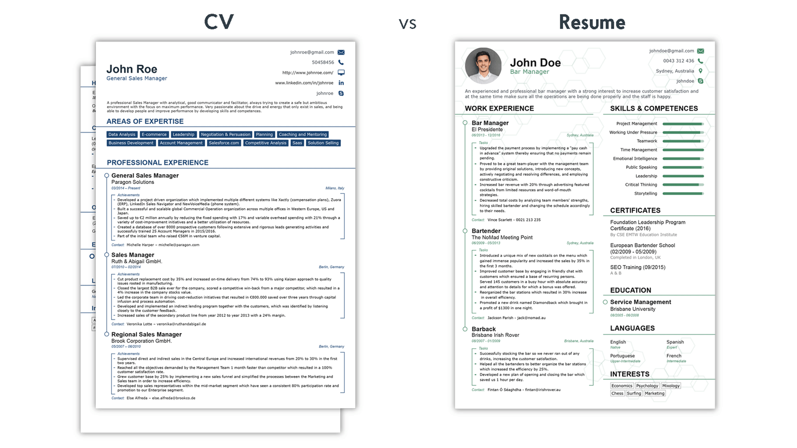

**Figure 2.1 Differences between CV and Resume**

#### Types of Resume

With regards to getting a job, there are a few types of resume. The table below shows the differences between them. Table 2.1 below shows the description of each type of resume.

**Table 2.1 Description of each type of resume** (Types of Resumes, 2019)**,** (Doyle, 2019)

|  |  |
| --- | --- |
|  | Overview |
| Chronological | Focuses on working history from the past till present, in reverse order. It also focuses on skills if needed. However, this type of resume is not suitable for those who have lack of working experiences and huge employment gap. |
| Functional | Emphasizes on skills and strengths that are important to the employers. It de-emphasizes the working history. However, this type of resume is not preferred by employers as it makes them to have a negative impression on the job applicants that try to hide their employment gaps or lack of experience. |
| Combination | Blends the flexibility and strength of both types of resume (chronological and functional). It shows off a strong employment record with upward mobility. Besides, it shows off how they use their skills in the past to apply for their next job. However, it is not the focus of the resume and typically does not take up much space. This type of resume is suitable for those who plan for a career change. |
| Targeted | It is highly focused on a particular job. It means to apply for different jobs, job applicants have to create separate resumes for different career paths. It is brief and easy to read. |
| Infographic | Instead of text, graphic design elements are used to display job applicant’s skills, qualifications, work experience and the like. Layout, colours, design, formatting, icons and font styling are the design elements to organize content. |
| Resume with profile | Supplements a profile section in the resume. One can provide a concise summary about their skills, experiences and goals that are relatable with the job they apply for. It is a way to “sell” themselves to the particular company. |
| Non-traditional | May include photos, graphics, images, other visuals and even videos. It might also be an online resume and act as a resume on social networking sites. It is ideal for people who are active in creative fields such as journalism and web design. |
| Mini | It is more than just a business card. It displays a brief summary of applicant’s career highlights and qualifications, only for the job that they want to apply for. It is useful at job fairs and career networking events. |

Among these types of resume, targeted resume is suggested to be used when applying jobs. It will be easier for employers to easily see and understand the relevance of a job applicant’s skills and experience to the particular job they apply for. It is well worth to put effort in this type of resume, especially when applying for job that is a good match with their experience and qualifications (Doyle, 2019). This type of resume allows them to update either adding or omitting as well as to customize it for the sake of satisfying the company’s job requirements.

#### Key Components of a Resume

A typical resume consists of some basic components, which are the header, summary statement, key skills and technologies, work experience and education. These are the parts that employers will expect to see regardless of what jobs the applicants are applying for. Table 2.2 below shows the description of key components of a resume.

**Table 2.2 Description of key components of a resume** (Buj, 2019)

|  |  |
| --- | --- |
| Key Components | Description |
| Header | The most crucial resume section. It contains name, contact information, address, phone number and email address. These are what the recruiters need to reach out to the applicants. Relevant website or LinkedIn URL can be included. |
| Summary statement | It follows the header and provides a short yet compelling description about career accomplishments and future ambitions. One can state the reason why they are the most qualified candidate for the job, highlight their most relevant skills and core competencies and the like. It is most likely to grab the attention from the recruiters. |
| Key skills and technologies | One can include computer skills, software skills and language skills. However, they must customize the skills they have in this section to match with the job description. Both hard and soft skills can be included but soft skills are much more important to the employers nowadays. |
| Work experience | Starts off with the most recent position followed by the past ones in reverse chronological order. For each position, company name, job title and employment date are included. Volunteer or unpaid experiences can be qualified as work experiences. |
| Education | Provides brief details of the academic qualifications in reverse chronological order. This section is placed below header (at the top of the resume) if applicants are looking for their first jobs since they leave their educational institutions, but for those who have been working that plan for a career transition, this section is placed at the bottom of the resume. |

To produce a great resume that may cause a higher chance of impressing a hiring manager or recruiter, it is important that the resume is structured in an organized manner. An organisable resume is to keep the font traditional, layout appealing and spacing consistent. It is to represent oneself professionally. Besides, seeking anyone to proofread the resume is crucial as well to ensure correct spelling and grammar. One also must list a professional-sounding email address and a phone number that is attached to a professional voicemail greeting.

In addition, subjective words such as “reliable” and “hardworking” must be left out of the resume. It is because when employers call applicants to attend an interview, they expect that applicants can solve a problem for them instead of them saying that they are reliable and hardworking. It is also vital to incorporate keywords listed in the job description into the resume. It will help to quicken the process of scanning the resume to see if the applicants are the perfect match. Brief explanation for employment gaps and layoffs must be given.

Moreover, a job applicant’s employment history is to be kept to 10-15 ears if the applicants have a substantial amount of industry-related experience. If the applicants are recent graduates, part-time jobs, internships, volunteer work, coursework, projects and even unpaid experience can be included in the resume. It is also vital to use the space of the resume effectively. It is always accompanied with a cover letter which contains the different content from the resume and matches with the job description. Applicants are to be expected to meet all the qualifications listed in the job description and include past experiences to reflect it (Owens, 2014).

### Ways to Build a Resume

There are a few ways to build a resume such as hiring a professional resume writer from a resume writing service, online resume builder as well as offline resume builder. Each of them has their own advantages and disadvantages. However, it is up to the applicants to choose which way they prefer to build a resume.

One of the ways to build a resume is to buy a resume writing service and hire a professional resume writer. It clearly states that the resume writers will take all the information provided by applicants and turn them into professional and formal-looking documents for a fee. Some applicants choose services when they have no confidence in their writing skills or when they repeatedly attempt to create their own resume which ends up being not responded by the hiring companies. Professional resume writing services guarantee resume writing because they have professionals who have proper training in writing effective resumes. The professionals also have knowledge about hiring practices. Since the resume written is effective, it will increase preference among employers when they scan through the resumes.

However, when there are many applicants out there acquiring those professional resume writing services, the resume templates for each applicant may be standardized. It means that there is a possibility that the contents look standardized and similar. There is a tendency that the writers use the copy-paste method. Besides, the fees for the services are very expensive. The writers might even charge more for their proofreading service (Anastasia, 2016). Malaysia’s first certified professional resume writer, hans.com.my provides resume writing service in addition to interview coaching and public workshops and training. Figure 2.2 below shows the website of hans.com.my.



**Figure 2.2 hans.com.my**

Another way to build a resume is to use an online resume builder. There are so many available online resume builders on the web. Using a resume builder saves a lot of time and money when searching a job because the resume templates are ready-made for applicants. They will not need to invest the time in researching what main sections should include in a resume, the content structure and finding suitable fonts and colours. The advantages of using an online resume builder are design skills are not required, unnecessary extra software purchase and the availability of professional and tested layouts. Besides, user information is saved online. However, some builders may have limited customization features and users may not have 100% control over the template (Kurtuy, Advantages & Disadvantages For Using a Resume Builder, 2017).

Moreover, offline resume builders are also used by some applicants. Such builders are Microsoft (MS) Word and WPS Office Word which provides free resume templates that look nice. However, MS Word has been not encouraged to build a resume using its templates because they are not built to be applicant tracking system (ATS) friendly and do not pass companies filters. ATS system is a piece of computer software that scans all the resumes that come in and eliminate all that do not fit the criteria set by the employers. Besides, the MS resume templates are too generic, which means they do not show any professionalism and character (Why Are Resume Templates In MS Word BAD?, 2019).

### Augmented Reality

AR provides users with a sensory experience beyond reality by seamlessly integrating virtual contents with the real world. AR evolves historically from the year of 1996 till today that emerges the dedicated AR devices and powerful development kits as well as improves the performance of mobile devices and sensor integration and advances in computer vision (CV) technologies. AR has brought benefits to such fields like entertainment, advertisement, education, navigation and maintenance. Pokemon Go, a location-based AR game has been popular till now since its public release in 2016. Web AR is the latest technology nowadays and is gradually emerging as a promising direction for mobile AR (Qiao et al., 2019). Figure 2.3 below shows the historical evolution of AR.

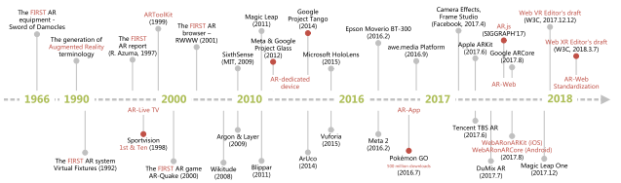

**Figure 2.3 Historical evolution of AR**

#### Mobile Augmented Reality

There are two dominant platforms for mobile Augmented Reality (mobile AR) for applications which are hardware-based and app-based. The current mobile AR hardware and operating systems that comprise of Embedded Linux, Android and iOS present a complex diversity. The advances in mobile devices, including computing and display platforms provide more choices for the implementation of AR applications.

Mobile AR has different implementation mechanisms with computing, networking and storage as the main complexities. The mechanisms are the sensor-based, vision-based and hybrid tracking methods. Sensor-based method is a lightweight approach where mobile devices support sensors like accelerometers, gyroscopes, compasses, magnetometers and GPS. The vision-based mechanism is where the camera provides the basis for vision based object recognition, detection and tracking which supports both marker-based and markerless methods. Marker-based method uses a predefined marker to meet the tracking requirement whereas markerless method detects and understands an unknown or outdoor real-world environment. It is currently using SLAM and collaborates it with other sensors to face the obstacle of computational inefficiency and limitations of the resources of mobile devices. Hybrid tracking mechanism combines different methods that increase the complexities of networking, storage and computational compared to the other mentioned mechanisms. Figure 2.4 and 2.5 below indicate the computational, storage and networking complexities for the three typical implementation mechanisms and marker-based methods respectively.

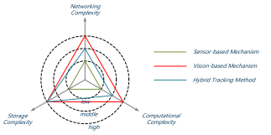

**Figure 2.4 Computational/storage/networking complexities for the three typical implementation mechanisms**

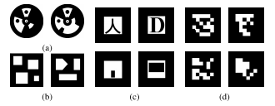

**Figure 2.5 Marker-based methods**

However, there are some downsides of mobile AR. The hardware-based implementation is costly and lacks of flexibility whereas the app-based requires additional downloading and installation. Most of its applications and solutions are designed based on a specific platform which causes the inconvenience for cross-platform deployment. To reach more users, an AR application needs to go through repeated development cycles to accommodate different platform which undoubtedly increases the cost of development and deployment (Qiao et al., 2019).

#### Web Augmented Reality

The birth of web Augmented Reality (web AR) is known to be the future promising direction for mobile AR. It is because of its lightweight, native cross-platform features and pervasive service provisioning of mobile AR. Thanks to the invention of the World Wide Web (WWW), it makes the web AR possible. The idea of using web in the technology of AR is that the web simplifies the service access for users, for example Facebook and Snapchat which they are designed in a hybrid way (native + web) way that provides a good interaction experience and cross-platform support.

However, there are some challenges when AR meets the web in real life. Compared to mobile AR, web AR has the limited computing and rendering capability that causes the degradation of the performance of web AR. It also hinders the fiducial tracking method that provides an accurate and robust tracking approach for web AR applications. Markerless mobile AR implementation is to be ported to the web. Another challenge of web AR is network delay. When web AR application is deployed into the cloud server, there are large communication delays, due to the limited data rate and unacceptable network delay which causes the difficulty for current mobile networks to support real-time operations like tracking and interaction.

Besides, web AR is a power-hungry application which is due to limited battery capability. The need for the sensors to cooperate over a long period of time, the analysis of the information, computing, communication and display puts tremendous pressure on the battery of the mobile device. Hence, the extreme energy consumption hinders the deployment of web AR. In addition, diverse enabling infrastructures also cause a compatibility challenge in terms of display platforms, operating systems and data formats. Besides, it is also challenging the development of web AR when it comes to supporting different sensor, display platforms and OS. The virtual contents crated by different tools also causes compatibility issue.

Regardless of the issues mentioned, there are two approached solutions that can solve the issues. Both limited computing capability and limited battery capability can be solved by offloading computation-intensive tasks to the remote cloud. It will accelerate the performance for web AR applications. Since they are dependent on mobile networks, the “browser + cloud” approach causes high latency and communication delays. It happens when getting data from the cloud server. But it can be solved by the 5G network, the upcoming advanced network technology in the future that provides higher bandwidth (0.1 – 1 GB/s) and lower network delay (1 – 10 ms), which improves data transmission on mobile networks (Qiao et al., 2019). With the 5G network, a new paradigm which is called mobile edge computing (MEC) provides cloud computing capabilities at the edge of networks close to mobile users and greatly reduces network latency (Qiao, Ren, Dustdar, & Chen, 2018). However, the deployment of web AR applications into the cloud server requires high monetary cost.

Figure 2.6 below shows the overall MEC framework for web AR. It shows the details of three processing components on the terminal, the edge cloud server and the remote cloud server.

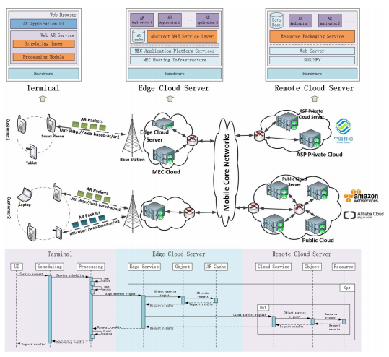

**Figure 2.6 Overview of the framework for web AR with mobile edge computing (MEC)**

##### Enabling Technologies for Web AR

There are some advanced web technologies emerging to meet the basic requirements of web AR as well as to improve performance. Such technologies are WebRTC, Web Assembly, Web Workers and WebGL.

WebRTC is one of the most important and basic technology that provides browsers with real-time communications. It allows the camera to capture the ambient environment in the form of a video stream as well as supports video coding, encryption, rendering and processing. Web Assembly is designed as a computational acceleration approach on the web by encoding procedures into a size-time-efficient and load-time-efficient binary format which can be executed on the web directly. It is to simplify the programming process and achieve native speed. It also solves the bottleneck problem of JavaScript and improves performance.

Web Workers utilizes worker threads to achieve parallelized computing, rendering, and resource loading in an asynchronous way. It provides a simple method for program parallelization of web AR applications, such as 3D model predownloading and parallelized feature points matching. It can provide users with a better experience, especially under the current mobile networks by scheduling and balancing the time and resource-consuming operations. WebGL provides a hardware-based GPU rendering acceleration approach on the web. It is important that it makes the presentation of AR smoother and more realistic on the web and it has a set of efficient JavaScript APIs for interactive 2D and 3D graphics rendering. Three.js is a WebGL-based JavaScript library (Qiao et al., 2019).

Figure 2.7 below shows the list of browsers for both desktop and mobile that can be supported by enabling web technologies.

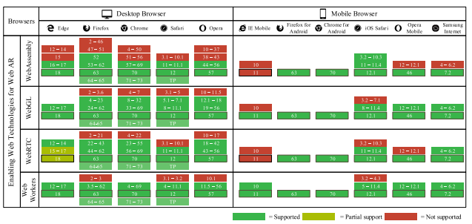

**Figure 2.7 Browsers support table of enabling web technologies**

##### Different Web AR Implementation Approaches

There are two types of approaches in implementing web AR which are self-contained method and computation outsourcing.

In self-contained method, there are two types of approaches. The first one is to develop pure JavaScript-based libraries or plug-ins. AR.js is an examples of web AR solution based on Three.js and JSARToolKit5 that can work on all platforms and any browser with WebRTC and WebGL. Another example is Awe.js that is based on natural feature tracking (2D image). However, this method has an inefficiency of computing capability. The other approach is to extend the browser kernel. It enables the web AR applications to get near-native performance on mobile devices and thus a better user experience. It is powerful but it is still in their infancy and have not been applied in practice on a large scale.

Computational outsourcing method leverages the computation and storage capabilities of the cloud servers and provides a better user experience compared to the self-contained method. It has stronger computing capability of the servers and reduces the computing capability requirement. However, network issues happen since web AR is dependent on mobile network, especially when it comes to this method. The network issue can be optimized by the 5G network (Qiao et al., 2019).

### Comparison Between Similar Existing Applications

There are some existing software applications that have been developed to create resumes, business cards and the like. Some of them have integrated with the AR technology. Each of them has their own functionalities, advantages and disadvantages as well.

#### NovoResume

NovoResume is a highly rated online resume generator. It has a few features and one of them is that it offers the ready-made professional templates such as functional, modern, simple, creative, basic, professional, college and executive. Besides resume templates, it also offers CV templates and cover letter templates. Figure 2.8 below shows the website of NovoResume.

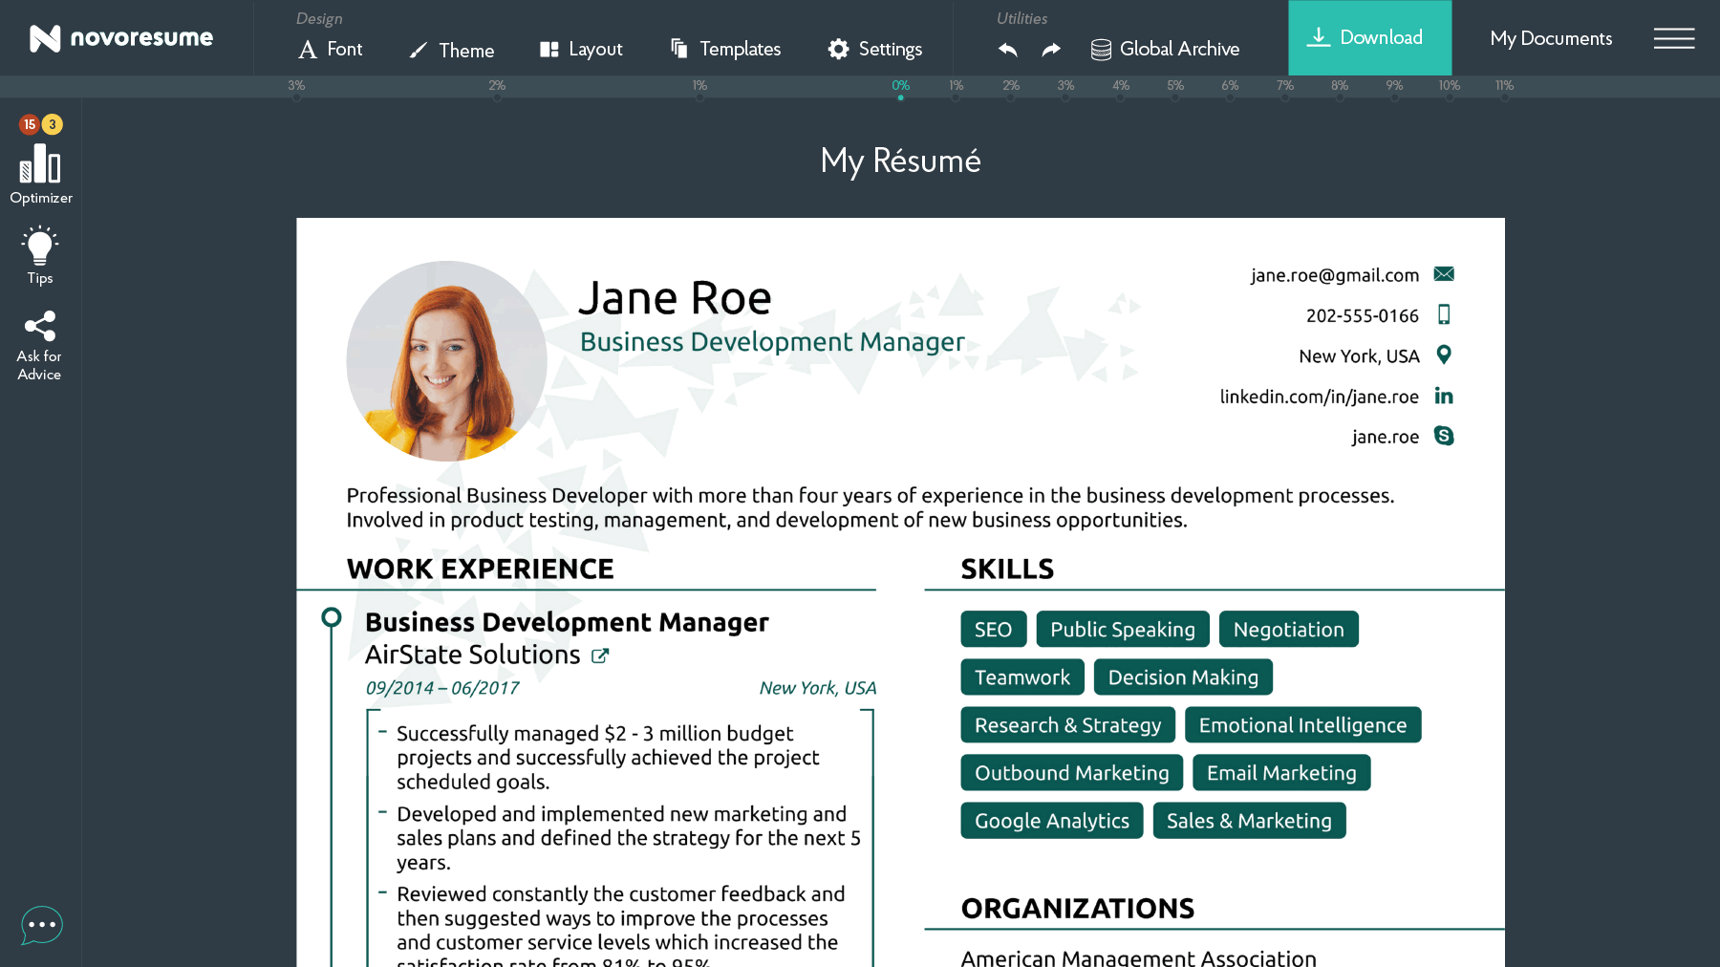

**Figure 2.8 NovoResume**

The layout is properly clean and it is easy to use. Account signup is required to access its features. To create a resume, what need to be done is to choose a template and fill up the details after signing up. However, it only provides free one-page downloadable resume and there are some pricing plans to unlock premium features such as cover letter, custom layout, more fonts, professional video tutorials, icons and the like. The pricing level varies in the range of $16 and $89.99 (Shahid, 2019).

#### Resumizer

Resumizer is a free online resume creator tool that generates different styles of resumes either ASCII text format or a style format. The style of resume simply means how the content of a resume is arranged. It provides only text inputs for overall content. In Resumizer, joining a free membership is optional for users. Without membership, users will need to export or print resume as the data will be lost when they leave the system. On the other side, with membership, users are free to save and update the resume. Section formatting highlights users’ strengths and minimizes weaknesses to optimize the resume (Free Resume Creator Online, 2019). Figure 2.9 below shows the input section for contact information in Resumizer.

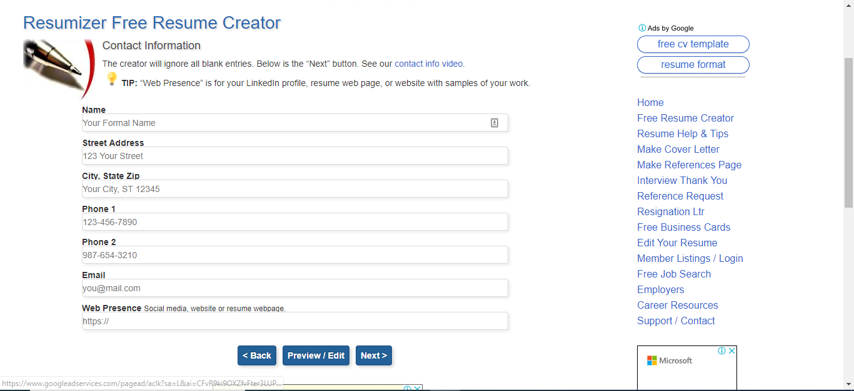

**Figure 2.9 Resumizer**

However, Resumizer only supports black and white templates, and the resume templates are plain. Instead of picture or photo upload from local file explorer, it only allows photo upload in Uniform Resource Locator (URL). In spite of the drawbacks, it offers guidance and tips on how to create a resume regarding the action verbs and keyword optimization. It also provides a spelling checking feature to correct the spelling mistakes.

#### SnapCard

SnapCard is a digital business card mobile application that uses AR as a cutting-edge technology to viewing business information. This application does not only limit to business cards, but brochures and product catalogues are welcomed to be transformed into viewable rich digital content on a smartphone. With SnapCard, it provides an integrated digital solution to showcase company’s business or organization. Users will be able to view animated or static 3D models and video presentation from companies or users’ profile as well as to share and save contact information via social media links when scanning the business cards. Figure 2.10 below shows the logo of SnapCard.



**Figure 2.10 SnapCard**

SnapCard is available in both Apple iOS and Android devices. To use this tool, users will need to create an account and create a personal SnapCard-enabled business card, followed by registering details in the app. It will transform the details into computer generated SnapCode so to allow users to share the generated digital business cards with other users. However, there is a billing plan subscription that ranges from free to $300 per annum. Billing subscription allows unlimited gallery videos and contacts, AR video, AR 3D models, media buttons and performance report (What is SnapCard ?, 2018).

#### YouAugment

YouAugment is a free online tool to build AR and Artificial Intelligence (AI) applications. It provides an easy yet powerful way to create AR and AI apps for the web, Android and iOS. It is easy to learn for anyone because it provides the essentials within the tool that brings AR/AI apps to life. It can be used in any kinds of fields such as creative, brand marketing, education and industrial. With this tool, users can create a variety of great experiences. As shown in Figure 2.11 below, it indicates the input section for users to create an AR or AI application in YouAugment.

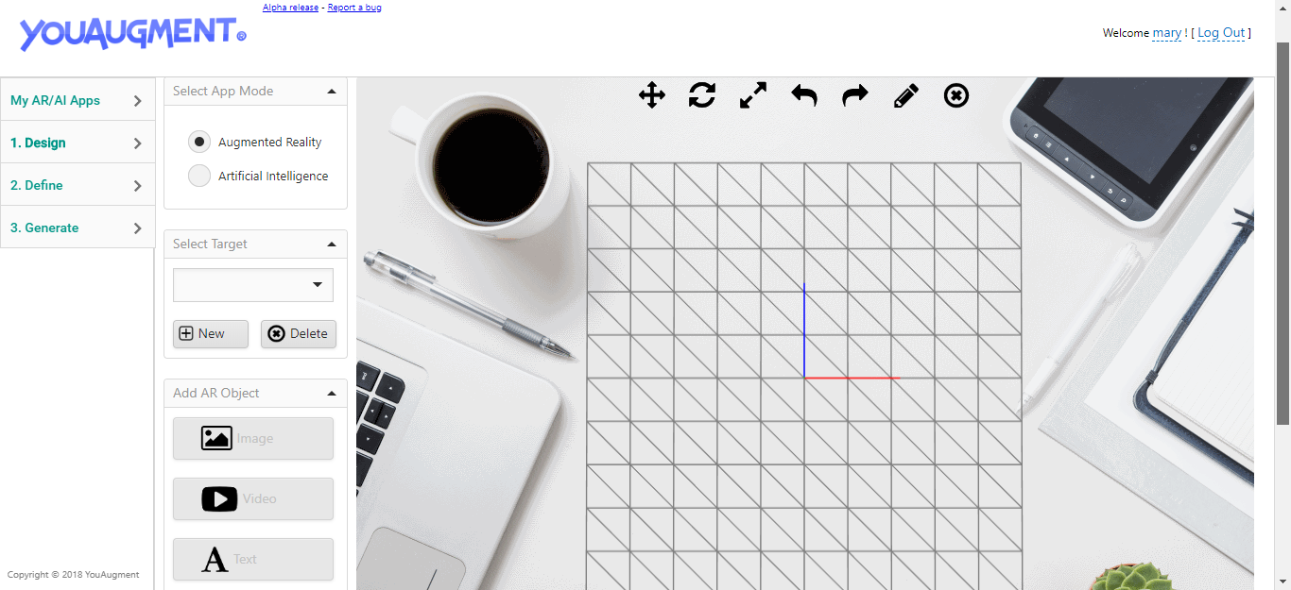

**Figure 2.11 YouAugment**

YouAugment is free for everyone, including the app source code. No coding skills and licences are required. The generated app from this tool has cross-platform support where it can work on the web, Android and iOS. In addition to cross-platform support and free usage, the generated app is hosted on YouAugment for free and is secured with Secure Sockets Layer (SSL). The app’s content is securely stored in the web server (Create Your AR & AI Apps for Free, 2018).

#### 8th Wall

8th Wall is an another online tool to build AR applications. It provides options for developers to choose from, which are mobile web AR, AR camera for prototyping and mobile AR applications for iOS and Android. However, each option has support limit. For mobile web AR, it only supports technologies like A-Frame, BabylonJS, Sumerian and three.js. The features provided by this tool include allow prototyping, create web AR apps that supports markerless-based and image targets that bring static content to life.

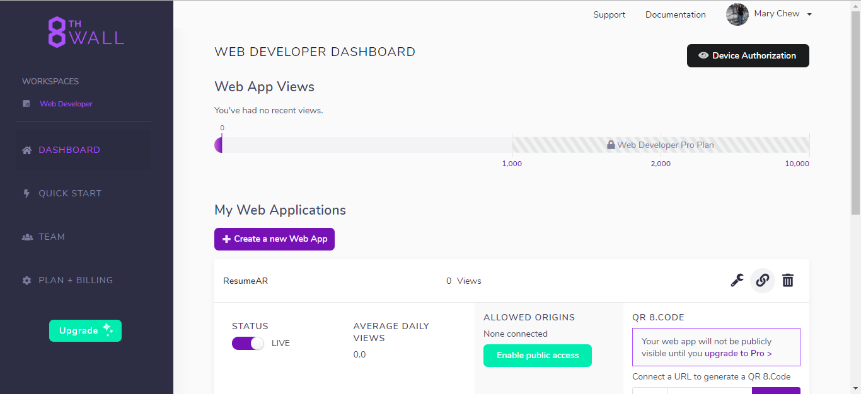

**Figure 2.12 8th Wall**

Figure 2.12 above implies the dashboard of 8th Wall for web developers once they have created an account. From the dashboard, they will be able to see how many views they gain from the audience who view the generated app, enable or disable public access to the generated app and an app key which they will be using to embed in their code. However, there is a billing subscription for them, ranging from basic to business plans. Billing is needed if developers intend to publish the AR app to the web for business purposes and get unlimited views from clients (True Web AR, 2018).

#### XR.+

XR.+ is an online web AR generator tool that allows users to publish photos, videos and 3D models in the AR on the web. It also allows users to build web VR applications. For AR, it only supports marker-based, hence a default marker is ready as a marker for users to scan. It is easy to use because no app is required as the AR and VR content can be done on the web. Interactive scenes can be created from images, videos and 3D models. This tool is suitable to use for marketing campaigns, museums, exhibitions and 3D artists. An URL will be generated to scan the marker to view the digital contents. However, billing subscription is needed to access more scenes, images and videos compositions, greater file size for 3D models, custom markers and available video textures and sound effects (XR.+, 2019). Figure 2.13 below indicates the workspace of XR.+ build web AR applications.

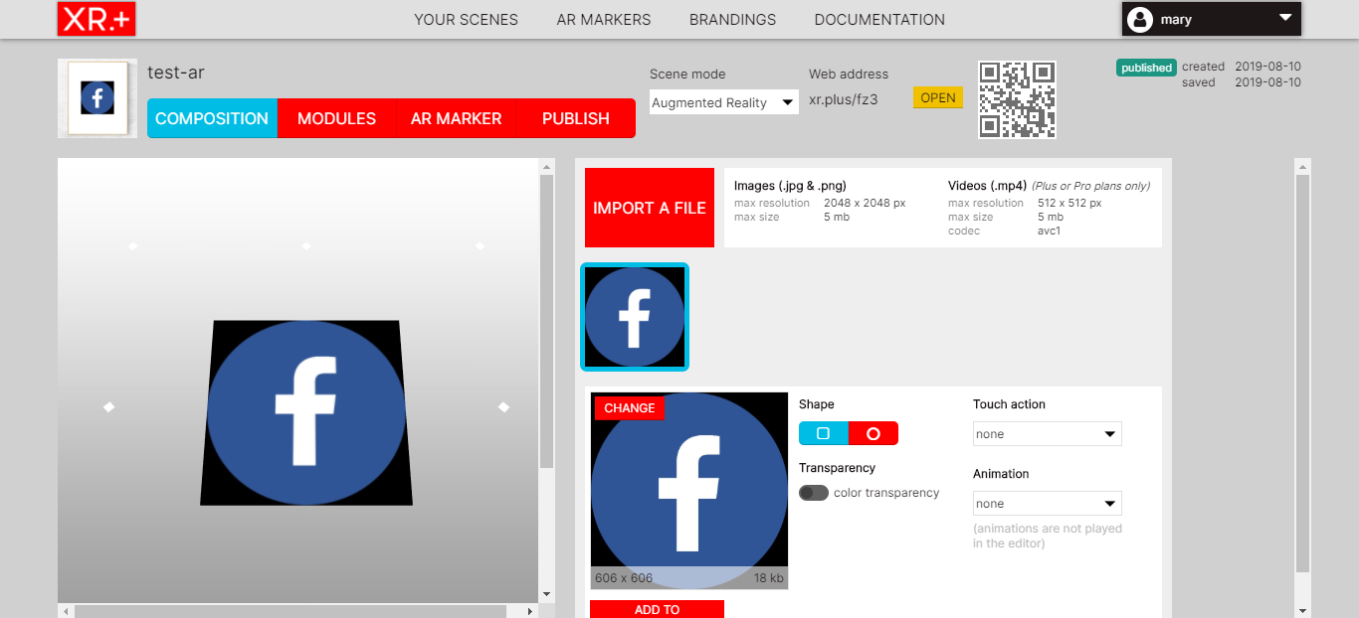

**Figure 2.13 XR.+**

#### Summary of Comparison in Existing Similar Applications

Table 2.3 below shows the summary of comparison among the applications that have been discussed. It shows the features covered by each application.

**Table 2.3 Summary of comparison between existing similar applications and proposed solution**

|  |  |  |  |  |  |  |  |
| --- | --- | --- | --- | --- | --- | --- | --- |
| Features | Image result for novoresume logo | Image result for resumizer logo | Image result for snapcard | Image result for youaugment | Image result for 8thwall | XR.+ |  |
| Free account signup | √ | √ | √ | √ | √ | √ | √ |
| File export | x | √ | x | x | x | x | √ |
| Free subscription | x | √ | x | √ | x | x | √ |
| Free resume download | x | √ | x | x | x | x | √ |
| Free customization | √ | √ | √ | √ | √ | √ | √ |
| Cross-platform support | x | x | x | √ | √ | √ | √ |
| Web AR support | x | x | x | √ | √ | √ | √ |
| Digital media upload | √ | x | √ | √ | √ | √ | √ |
| Produce augmented contents | x | x | √ | √ | √ | √ | √ |
| Free hosting for AR apps | x | x | x | √ | √ | √ | √ |
| Free publication for AR apps | x | x | √ | √ | x | √ | √ |
| Marker-based support | x | x | x | √ | x | √ | √ |
| Generate sharable URL | √ | x | √ | √ | √ | √ | √ |
| Create augmented resume | x | x | x | x | x | x | √ |

### Summary

This section highlights the importance of resume for both job applicants and hiring manager when it comes to securing their job. In the perspective of a hiring manager, a professional resume decides if a job applicant is hireable. To save time and money, an online resume builder is the top choice for job applicants. Besides, this section also highlights the differences between mobile AR and web AR as well as their pros and cons. Some enabling technologies and different implementation approaches have made web AR possible. Finally, similar existing applications and the proposed system, AResume have been compared in terms of features.

# 

## METHODOLOGY

### Introduction

This chapter introduces the methodology being used in AResume, which is rapid application development. It also explains the phases of its development as well as the tools and frameworks from software technologies that are used to build the application.

### Rapid Application Development

Rapid Application Development (RAD) is a methodology of Software Development Life Cycle (SDLC). This model is a prototyping-based and its development is iterative. It focuses more on user requirement gathering through workshops and focus groups, early testing of the prototypes by the users using iterative concept, reuse of the existing components, continuous integration and rapid delivery.

In RAD, the functional modules are developed in parallel as prototypes and are integrated to make the complete product which will ease the product delivery faster. It only requires minimal planning, hence any changes can be incorporated within the development process easily (SDLC - RAD Model, 2019). It comprises of 4 stages which are requirements planning, user design, construction and cutover. Figure 3.1 below shows the phases of RAD.

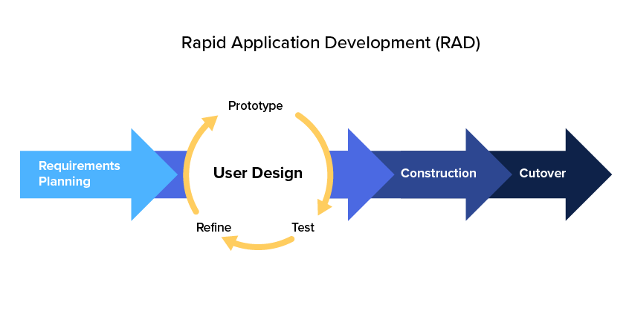

**Figure 3.1 Rapid Application Development**

RAD is chosen to be used in AResume because AResume comprises of two kinds of development, which are web development and augmented reality. It needs rapid development as it has much more complexities to work on. Errors and bugs will more likely to be found during the development, hence fixing bugs and implementing new features will be carried out in parallel for rapid production. RAD is chosen over other methodologies in SDLC because this method can adapt with ad-hoc requirement changes, rapid development with reduced time, quick reviews and the priority of user feedback (RAD, 2018).

### Project Development

The project development of AResume is separated into a few phases, comprising of requirement gathering, design, development, implementation and testing. Figure 3.2 below shows the phases to be carried out during the whole development of this project.

**Figure 3.2 The break-down phases of AResume development**

The whole application development will break down into 3 phases which are system design, web application development and web AR integration. In the system design phase, the design of the use case and sequence diagrams, database as well as user interface will be planned out. Sequence diagrams will show the flow of how the application goes and it consists of users who will use the application as well as the functions performed when using it. Database design will imply how the database looks like. It includes data in the form of tables and the relationships between them. In addition, user interface design shows how the web application looks like that includes components such as navigation bar, forms, user inputs, buttons as well as the link between pages.

In the web application development phase, user input, expected output and GUI from this application are applied into the consideration. Components such as forms, buttons, images, text and functions will be integrated in the web for users to interact with the web application. The application will be coded and developed based on the design done in the system design phase. Front-end design and back-end functions such as building a database and creating a server are included in this phase. PHP, Bootstrap and jQuery are the main frameworks.

In the web AR integration phase, user input for uploading the digital elements will be developed. The digital elements can be documents, pictures or videos. They will be displayed as augmented features in the application, where they will be shown when users scan the resume. Ar.js and A-Frame are the main tools.

### Development Technology

Tools and frameworks are important when it comes to development. In this project, only software technologies are used. They are to build the user interface that creates user experience in the front-end. This is where users will see and understand the how the whole application looks like. Besides, they are also used to build the functions as well as create a server and a database in the back-end.

#### Bootstrap

Bootstrap is one of the mostly widely used CSS frameworks. It is chosen to use in this project is because of it is easy to use and has a great grid system. It is a front-end framework that build responsive websites. Besides that, it has bundled JavaScript plugins to make components such as drop-down menu as well as accordions and sliders to be interactive. (Chouhan, 2017) Bootstrap is said to be compatible with all modern web browsers such as Chrome, Firefox, Internet Explorer, Safari and Opera. It is easy to set up and is fully customizable. (Segal, 2019) Figure 3.3 is a logo of Bootstrap.



**Figure 3.3 Bootstrap**

#### jQuery

jQuery is a JavaScript library which is used to design to simplify the client-scripting of HTML. It is chosen to use in this project because it promotes simplicity. Due to its simplicity, it is easy to learn and it is built on shorter and simpler code. It has a lot of components which are robust that can be plugged into the website. Moreover, jQuery pages load faster and it is lightweight. Because of its lightweight feature, jQuery pushes content to the client which will reduce the waiting time to serve the response. It is compatible in any web browsers and most importantly, it is free (Hein, 2012). Figure 3.4 below shows the logo of jQuery.



**Figure 3.4 jQuery**

#### PHP

PHP is a general-purpose programming language, and also known as a server-scripting language. It is free and widely used, especially in web development. It is chosen because it can work and interact with different database languages, in this case, MySQL. It is said to be cheap and easy to set up. It can run on Windows, Linux and Unix servers. One of its good qualities is that it is dynamic and does HTML rendering. With PHP, the web servers have been configured to take care of the pages. It is open-source as well as high-level, loosely and dynamically-typed (David, 2018). Figure 3.5 below is the PHP logo.



**Figure 3.5 PHP**

#### MySQL

MySQL is a relational database management system based on Structured Query Language (SQL). It is used for a large variety of purposes such as data warehousing, logging applications and e-commerce websites. The main purpose of MySQL in this project is the web database to store information regarding users and their resumes as well as it is associated with PHP. With the association with PHP, it will interact with the website in real-time to display the information to the user instantly (What is mySQL and why do I need it?, 2019). It is open-source, reliable and compatible with any hosting providers. Besides, it is cost-effective and easy to manage (Branson, 2017). Figure 3.6 below shows the logo of MySQL.



**Figure 3.6 MySQL**

#### AR.js

AR.js is an efficient AR solution on the web, which means it makes the web AR possible. Jerome Etienne is the father of this framework, who is a JavaScript and WebGL guru. It is efficient because it is many times faster than its predecessors. It is said to clock 60fps (frames per second) on a 2-year-old phone. This framework has both WebGL and WebRTC that allow AR to be accessible in any mobile devices, even phones and laptops. It is an open source tool hence it will still extend AR’s reach to all devices without demanding high system requirements (Bhatt, 2018). Figure 3.7 below is the logo of AR.js.



**Figure 3.7 AR.js**

In AR.js, only marker-based application is supported. Hence, developers are free to customize markers for development use. There is a marker generator called AR.js Marker Training specifically for marker personalization. This marker generator only supports two types of markers which are pattern and barcode (Etienne, 2017). The marker generated will be used in the resume and it will need a URL to it. Figure 3.8 below shows the website that trains a marker for any web AR purpose. Whereas, figure 3.9 below shows both barcode and pattern markers.

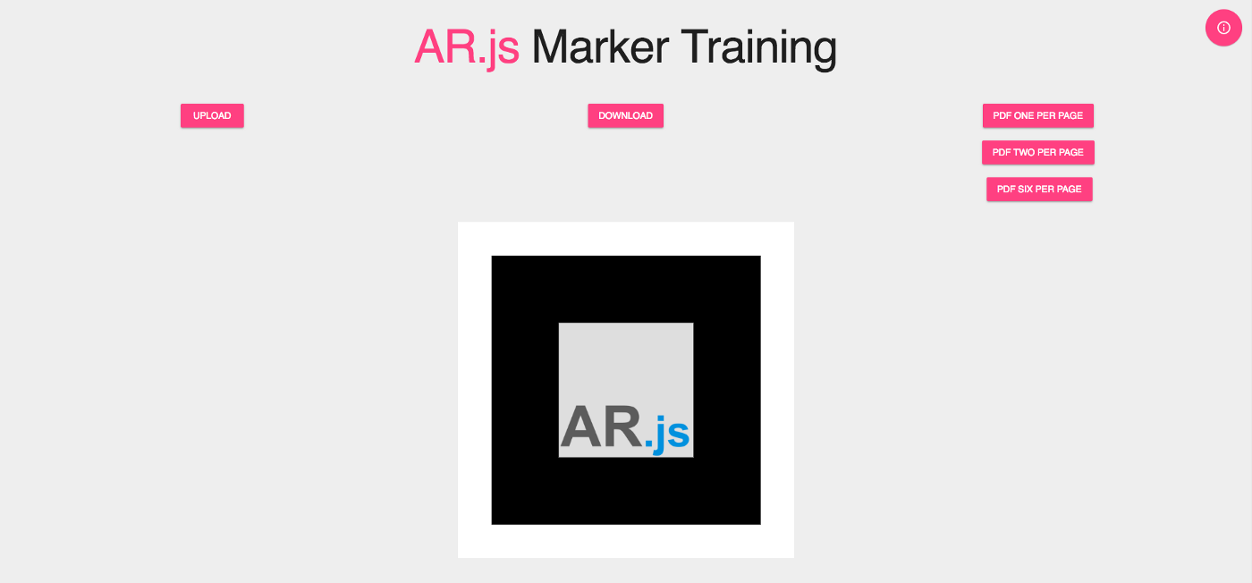

**Figure 3.8 AR.js Marker Training**



**Figure 3.9 Barcode and pattern markers**

#### A-Frame

A-Frame, originally conceived within Mozilla is an open source web framework to build virtual reality (VR) experiences. It is an entity component built on top of Three.js as well as HTML, hence it is pretty simple for developers to build web VR applications. It is powerful because it provides a declarative, extensible, and composable structure to Three.js. It is gradually maintained within Supermedium, hence it is powerful to develop VR content. The features of A-Frame are optimized performance, declarative HTML, entity-component architecture, cross-platform support, better scalability for a vast amount of companies such as Google, Disney, Samsung, Toyota and the like. It also has components available such as animations, lights, materials and geometries (Introduction, 2019). A-Frame is chosen to work with AR.js because it builds 3D scenes for the web (Huynh, 2019). It will be useful to use this framework in AResume to load the components in the application. Figure 3.10 below is the A-Frame logo.



**Figure 3.10 A-Frame**

#### 000webhost

000webhost is a free web hosting service which provides free domain name. It manages the user account easily with cPanel control panel as well as the entry-level plans that support PHP and MySQL. This project is used in this service and 1GB of disk space and 10GB of bandwidth are provided for the purpose of small-scale project (McGath, 2019). Figure 3.11 below is the logo of 000webhost.



**Figure 3.11 000webhost**

### Summary

As discussed in this chapter, the development process in this project is Rapid Application Development. The project development breaks down into several phases, ranging from system design to web AR integration into the web application. During the development phase, building an application would be done in parallel with bugs fixing. Some relevant web technologies are mentioned in both web development and web AR, which will be used to develop the overall application.

# 

## ANALYSIS AND DESIGN

### Introduction

This section introduces the overall design and implementation of AResume. User requirements are listed in this section as well as the system flow of the application in terms of use case and sequence diagrams, which help readers to understand how the AResume works. The initial GUI of this application will be sketched for better visualization.

### Survey Analysis

A survey has been conducted to acknowledge the opinion of the respondents regarding the project. Google Form is utilized to create the survey form. There are three sections which are demographic information, experience in building a resume and some opinion in building AResume. The number of the respondents is 50 in total.

Figures 4.1 below shows that the respondents who respond to the survey comprise 56% males and 44% females.

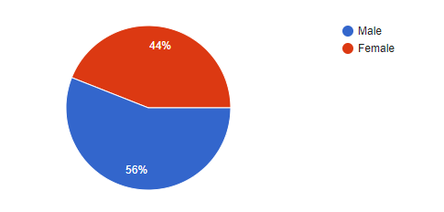

**Figure 4.1 Percentage of respondents by gender**

Based on Figure 4.2 below, the majority of the respondents is in the age of 18 to 24 years old (80%), followed by 16% of the respondents who age between 25 to 34 years old and 4% who age between 35 to 44 years old.

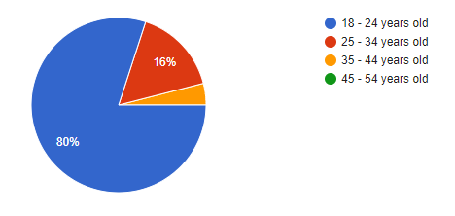

**Figure 4.2 Percentage of respondents by age**

Figure 4.3 below indicates that 60% of the respondents are students, 30% are employed full-time, 6% are unemployed yet looking for job, followed by 2% who are employed part-time and 2% who is unemployed and not looking for job.

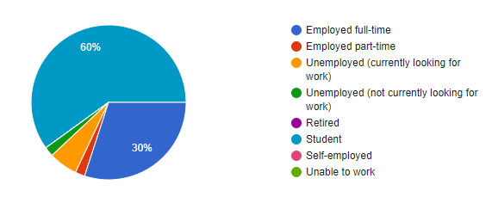

**Figure 4.3 Percentage of respondents by their current employment status**

Figure 4.4 below implies that the majority of the respondents involve in Information Technology and Computer Science (56%), followed by Education/Training/Teaching (20%) and Engineering (16%).

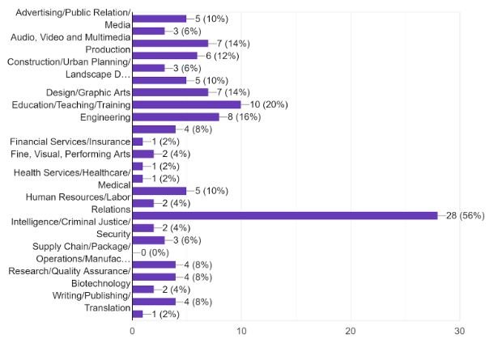

**Figure 4.4 Career areas involved by respondents**

Figure 4.5 below shows the frequency in using different ways to build the resume. The majority of the respondents use word processors such as Microsoft Word and WPS frequently and always, followed by online resume builders and photo editing software such as Adobe Photoshop.

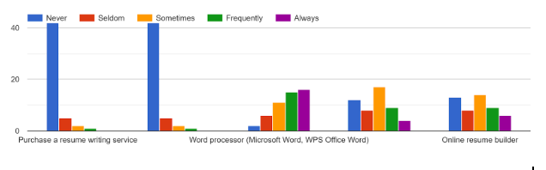

**Figure 4.5 Frequency in using different ways to build the resume**

In Figure 4.6 below, the most widely used software and websites by respondents to build resume are Microsoft Word, Canva, Novoresume and resume.io.

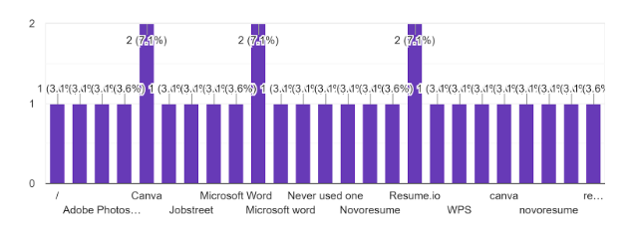

**Figure 4.6 Names of the resources to build resume**

Figure 4.7 below indicates the satisfaction gained by the respondents after using the different ways of building resume such as resume writing service, hiring a professional resume writer, word processor, photo editing software and online resume builder. Based on the figure, especially online resume builder, the dissatisfaction and less satisfaction of the respondents have outnumbered the extreme satisfaction.

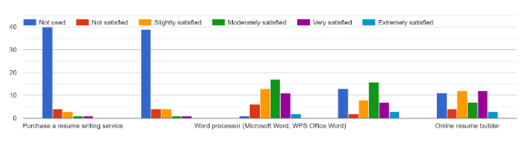

**Figure 4.7 Satisfaction gained from using the resources to build resume**

Figure 4.8 below shows the challenges faced by respondents when building resume. The challenges are the problems in starting a resume from scratch, designing a resume, adding medias such as videos and photos, creating a 1-2 page long of resume, spending too much time in creating a resume, presenting their portfolio to impress the hiring manager as well as building a resume is a tedious work. Majority of the respondents agree that they face those kind of challenges when building one.

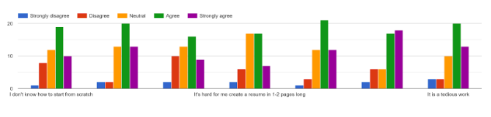

**Figure 4.8 Challenges faced in building resume**

Figure 4.9 below shows the importance of the contents which will be displayed with augmented reality (AR) feature in the resume. Contents that are highlighted are videos, photos, social medias, websites, certificates and transcripts. Based on the figure, the extreme importance of these contents have outnumbered the less importance and no importance. It explains that it is important to include those kinds of contents in the resume.

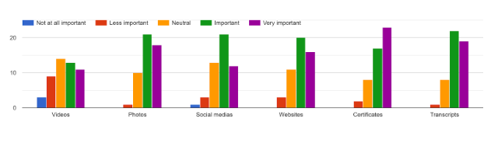

**Figure 4.9 Importance of the contents displayed with AR**

Figure 4.10 below indicates the preference for features proposed in the AResume. Such features are importing information from LinkedIn, generating sharable URL for the particular resume, creating augmented resume, exporting resume into different file formats as well as scanning the resume to view the augmented contents. Most of the respondents prefer these features.

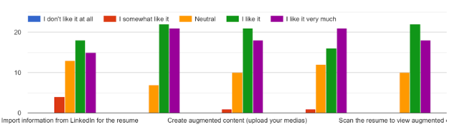

**Figure 4.10 Preference for features in AResume**

Figure 4.11 below indicates the importance of attributes in AResume. Such attributes are simple yet attractive user interface, efficient and user-friendly system, less time needed to load the system, portable system that can run in different mobile devices as well as the security of the system. Based on the figure, majority of the respondents agreed that these attributes are important in AResume.

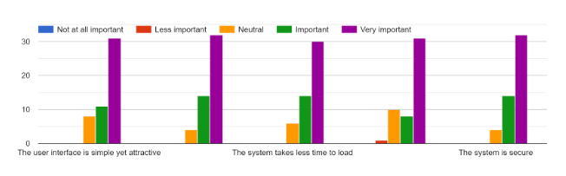

**Figure 4.11 Importance of attributes in AResume**

### User Requirements

The target audience for this application is the job applicants. Requirements from job applicants are clearly stated in this section to understand what they expect to do with it.

#### Functional Requirements

Figure 4.12 below is the use case diagram in AResume for job applicants that lists out the functional user requirements that are included in this project. It clearly states that the functionalities in this project allow users to:

1. Create user account
2. Choose a resume template
3. Build a resume
4. Upload digital medias
5. View generated sharable link
6. Scan markers on the generated resume
7. Export resume into different file formats
8. Download resume
9. Edit and delete resume

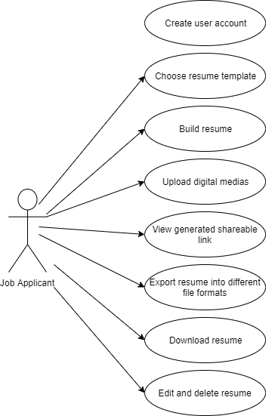

**Figure 4.12 Use case diagram for job applicants**

#### Non-Functional Requirements

Non-functional requirements are the requirements that are taken account into consideration when it comes to software development. Such requirements involved in AResume are performance and network optimization. These requirements are to define the quality attribute of the application.

AResume is a web AR application which is lightweight and has less computational tasks. When scanning the resume, the application shall respond to any user interaction such as playing video and navigating to another URL within 5 seconds or less. Besides, the result, in that case the AR contents should appear as the response within 5 seconds or less as well. it will less affect the performance of the AR experience negatively.

Another requirement to be considered in this project is the network optimization. Loading information from the cloud will cause communication delays, hence it requires faster data rate. Current network technologies are 3G and 4G. However, 3G mobile network causes higher latency (Ferber & Rauber, 2012) compared to 4G with the network speed of 5-12 Mbps. The AR contents shall appear as results in 4G mobile network. The introduction of 5G network that has 1-10 Gbps network speed (What is the difference between 3G, 4G and 5G?, 2019) in cloud computing in the future will solve the communication delay issue and improve network bandwidth as well as reduce latency. Hence, in AResume, both 4G and 5G network are put into consideration which will further improve the speed of getting data from the cloud server, especially when rendering augmented features in the mobile devices.

### Sequence Diagram

A sequence diagram depicts the interaction between objects in sequential order where these interactions take place. It is to understand the requirements of an application (Jain, 2019). There are a few sequence diagrams that have been drawn below to show the interaction between job applicants and AResume.

Figure 4.13 below shows the sequence diagram of user sign up and sign in. Upon opening the application in the web browser, users will create a user account. Their sign up information will be stored into a database. After signing up, they will get a message stating that they have created their account successfully. When they sign in to the application, they will be redirected to the resume dashboard. If they sign in with invalid credentials that causes failed validation, a message will be shown to them, stating that they are unable to sign in.

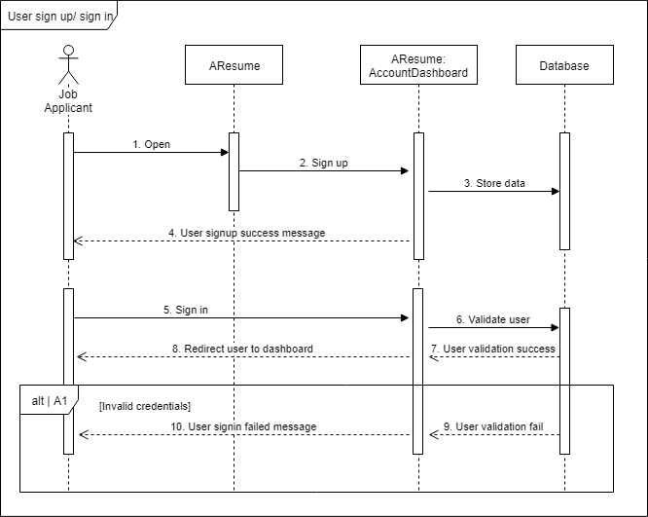

**Figure 4.13 User sign up/sign in sequence diagram**

Figure 4.14 below shows the sequence diagram of building resume. In the application, users will choose a resume template, provide necessary inputs for each section like personal information, education, work history, activities and awards to the resume and upload digital medias into the resume. Once the resume is created, a link will be generated to view the resume online. The PDF of the resume is generated as well. All the related information in the resume will be stored into the database. A message will be shown to the users stating that they have created the resume successfully.

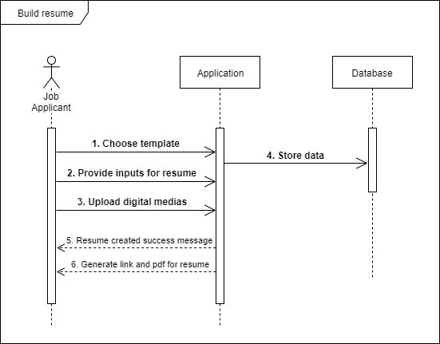

**Figure 4.14 Build resume sequence diagram**

Figure 4.15 below shows the sequence diagram of managing resume. The information of the resume is retrieved from the database and is displayed in the dashboard. In the dashboard, users can view the resume online associated with an URL, export and download the resume. Besides, they can edit and delete the resume, which will update the information in the database. Once the update and delete operations succeed, a message will be shown to them stating that they have updated or deleted the resume successfully.

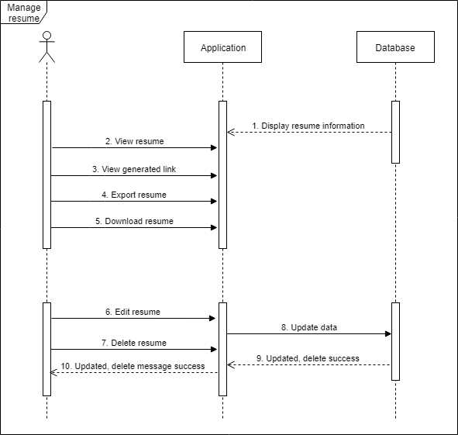

**Figure 4.15 Manage resume sequence diagram**

Figure 4.16 below shows the sequence diagram of scanning resume. When viewing the resume online, QR code is attached to the resume. Upon scanning the QR code using a QR code scanner application, users will be redirected to the AR scanner website. When they open the scanner for the first time, they will be prompted to allow access to open the camera. When the permission to the camera allowed, they will scan the markers on the resume and the augmented features which they have uploaded in the resume will be displayed in the mobile devices.

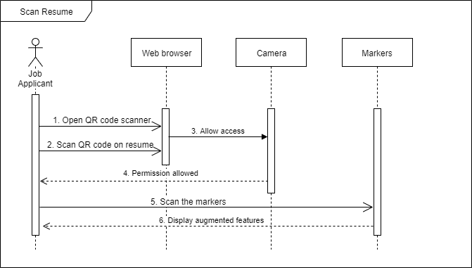

**Figure 4.16 Scan resume sequence diagram**

### Database Design

Figure 4.17 below indicates the database design of AResume. All information about the user and resume are stored in the database. The tables in the database are shown in the figure below, namely user, template, template_temp, profile_temp, institution_temp, activities_temp and award_temp. Each table is provided with an ID, which is known to be the primary key. The tables that range from template_temp to award_temp are associated with user_id and resume_id as foreign keys which relate them to the template_temp and user tables. Hence, the figure shows the data classification and the interrelationships between the tables.

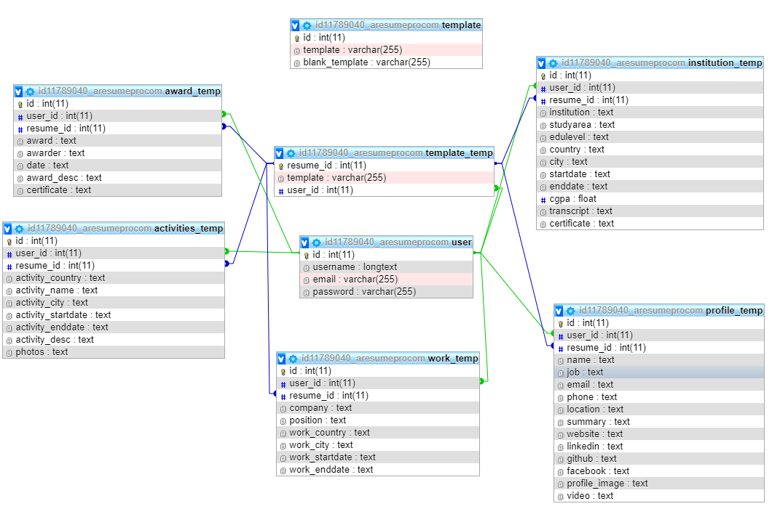

**Figure 4.17 Database design of AResume**

### Component Diagram of AResume

Figure 4.18 below is the component diagram of AResume, which explains the overall system architecture of AResume. First and foremost, the user inputs the data in various format such as text, video, photos and documents for a particular resume through a web application in a browser. All the data will be stored in the database. The web application and database is hosted with 000webhost that provides free web hosting. Through the web application, the user is able to view information of the resume.

Video, photos and documents are all embedded into the AR marker. The user opens the QR code scanner using a smartphone and scan the QR code that embeds an URL which directs the user to the AR scanner website. Then, the user scans the markers on the resume and the contents (video, photos and documents) uploaded by the user will be able to see the contents as AR features in the phone. The user can move the scanner from marker to marker to view different contents.

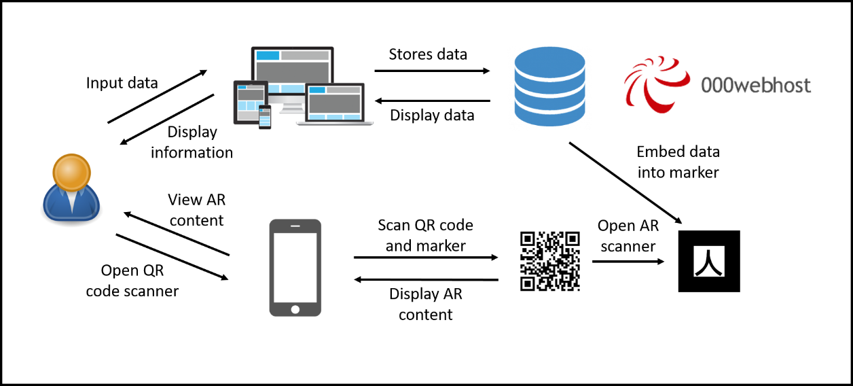

Figure 4.18 AResume system architecture

### Summary

In this chapter, analysis of the survey has produced the results that the digital media upload as the main function in the resume is important. It is because users can attach any certificates and other attachments to the resume. both functional and non-functional requirements of AResume are explained as well as the sequence diagrams that are drawn out to clearly explain the sequential flow of the interaction between job applicants and the application. Besides, database is also designed to understand what data is to be stored and how the data interrelates. Finally, an overall system architecture of AResume has sketched out to provide a clear picture of how it works.

# 

## IMPLEMENTATION AND DISCUSSION

### Introduction

This chapter explains the implementation of the project and some discussion about the result after the implementation. It consists of the graphical user interface of the web application as well as the libraries and source code of the application. This chapter also discusses about some test evaluation.

### Graphical User Interface

This section indicates the layout and user interface of AResume. Each of the user interface will be explained about its function.

Figure 5.1 below indicates GUI of the user sign up and sign in form. It is where users will create a user account and then proceed to sign in, in order to redirect to the dashboard.

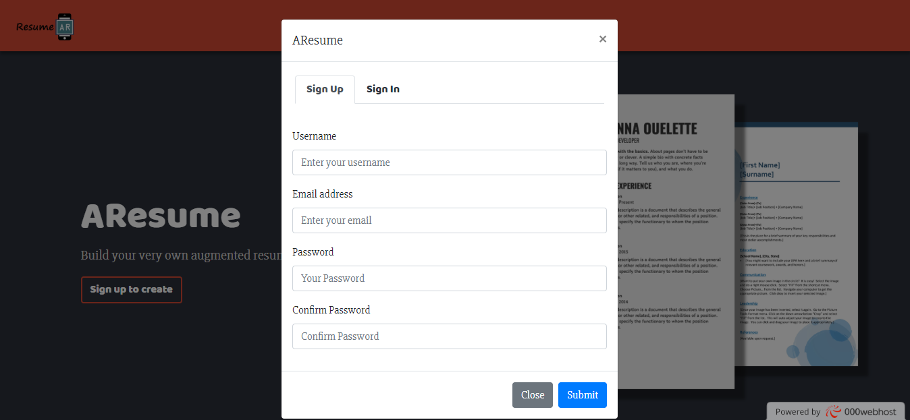

**Figure 5.1 User sign up / sign in form**

Figure 5.2 below shows the GUI of resume dashboard. There are several buttons which users can manage their resume like view, downlaod, edit and delete resume. Users will be able to create a resume as well by clicking the create button.

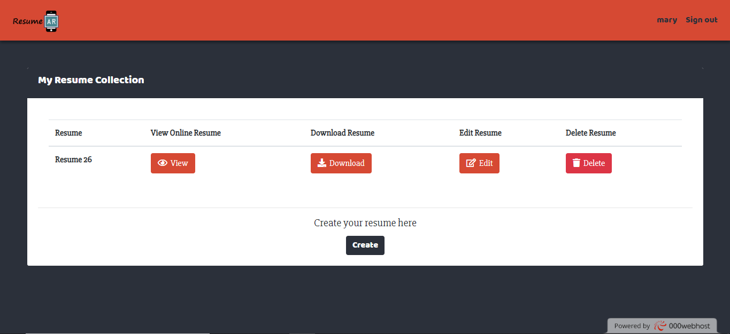

**Figure 5.2 Resume dashboard**

Figure 5.3 below shows a set of templates where users can choose a preferable template before creating a resume.

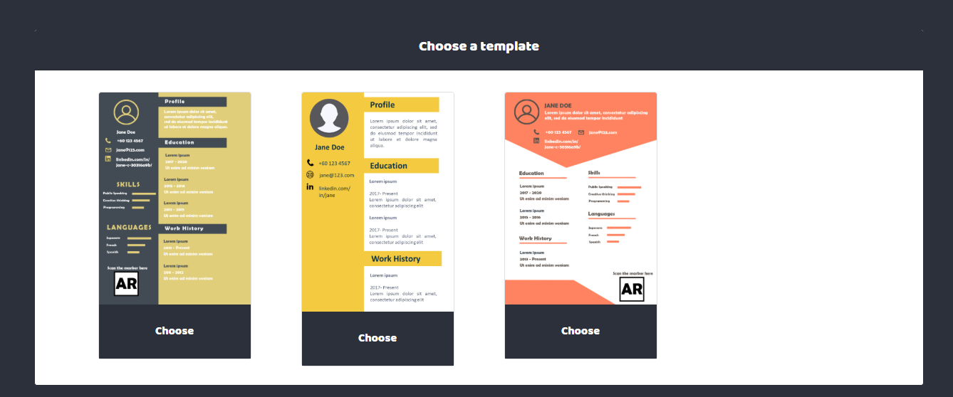

**Figure 5.3 Choose a template**

Figure 5.4 below shows GUI of the profile section. Users provide input about their personal information and can upload a video if they have any. The content of the video can be the self-introduction of the user and other relatable information. Those who involve in creative arts, video is a great way to showcase their artworks. The video is optional. There is a resume completion progress bar to show the completion progress.

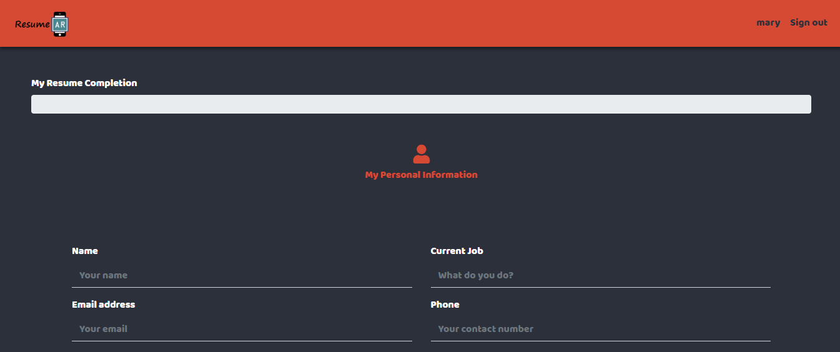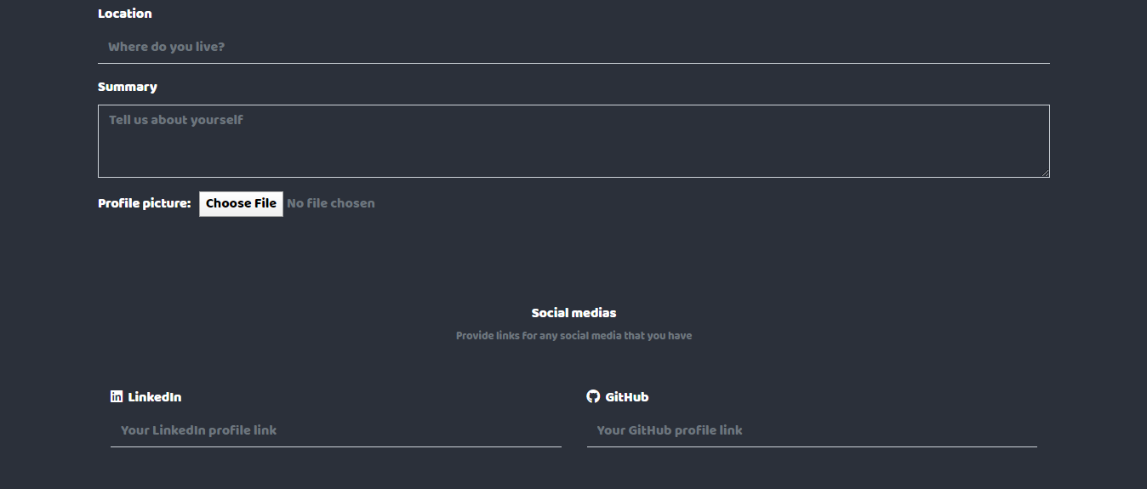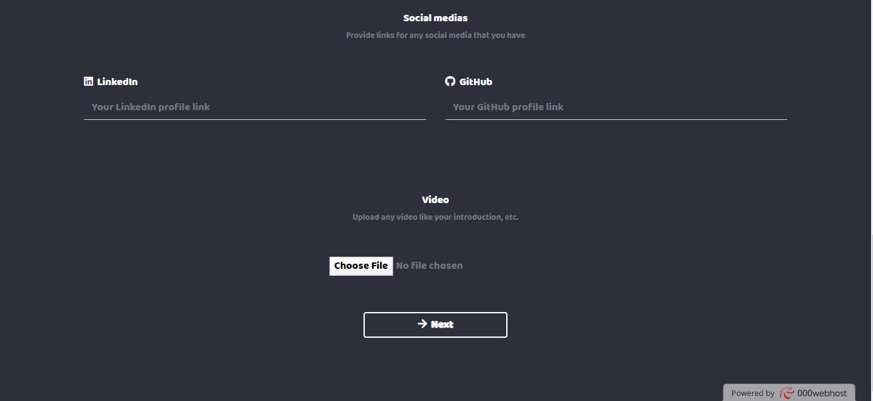

**Figure 5.4 Profile section**

Figure 5.5 below shows the GUI of the education background section. Users provide input about their education background and they can upload a transcript and certificate (graduation certificate) for the particular institution. In the progress bar, the red bar shows that the profile section has completed.

**Figure 5.5 Education background section**

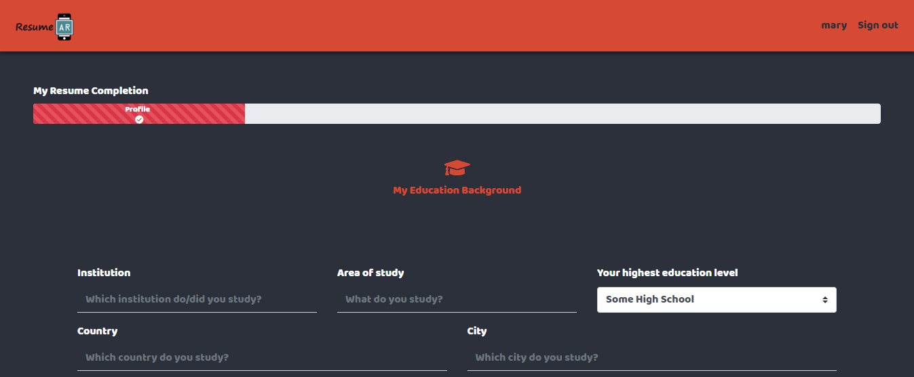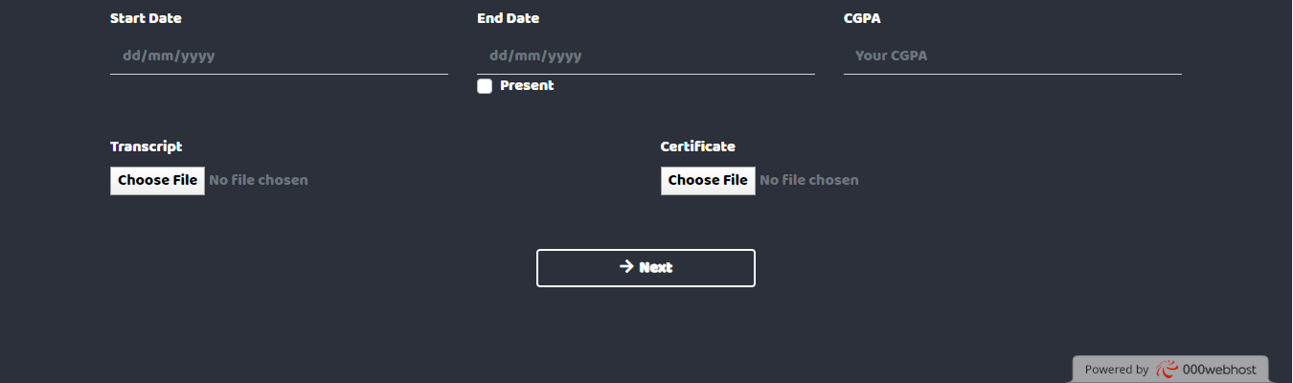

Figure 5.6 below depicts the GUI of the work history section. Users provide input about their work history. The yellow bar in the progress bar shows that the education section has completed.

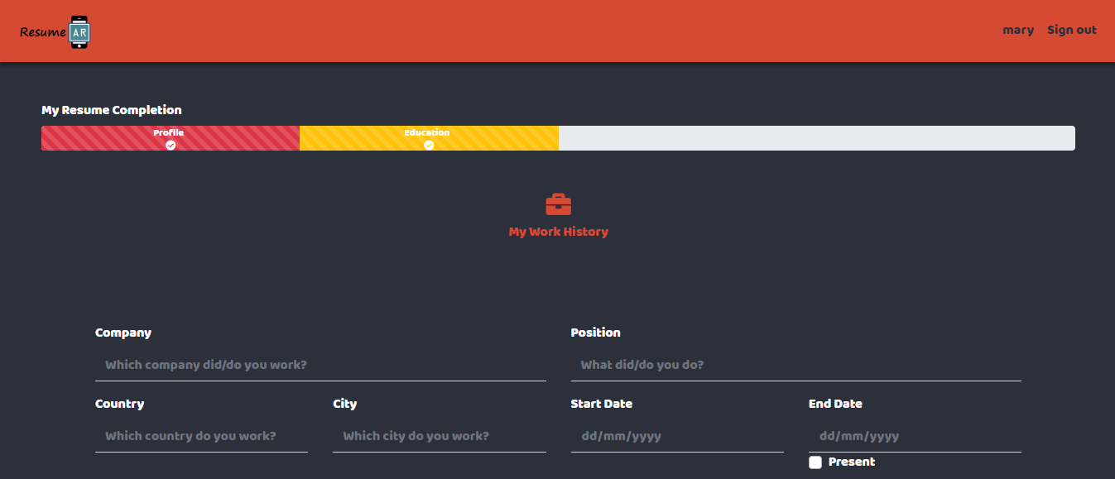

**Figure 5.6 Work history section**

Figure 5.7 below shows the GUI of the activities section. Users provide inputs about the activity they have participated and can upload a photo of the particular activity if they have any. The blue bar in the progress bar depicts that the work history section has completed.

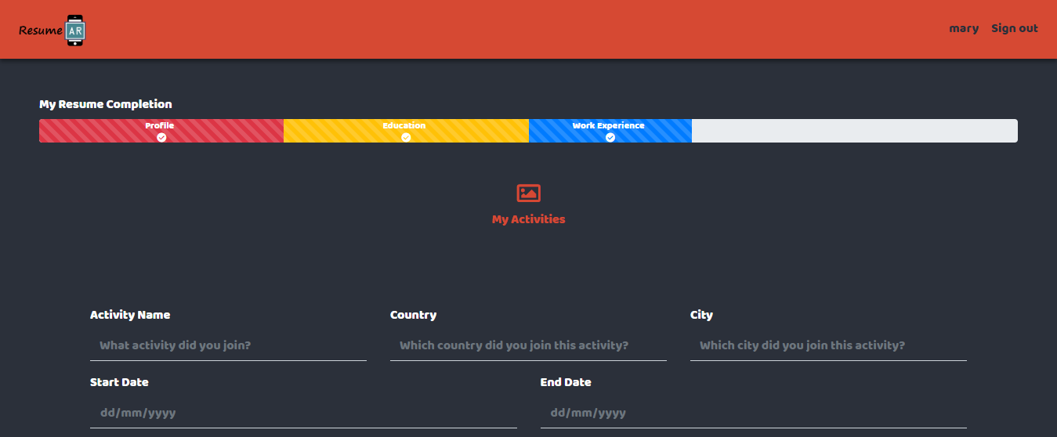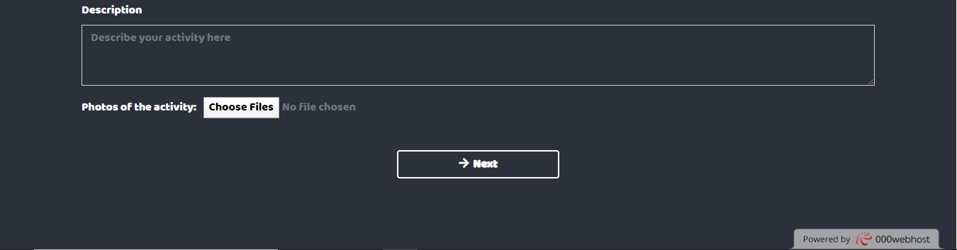

**Figure 5.7 Activities section**

Figure 5.8 below indicates the GUI of the award section. Users provide inputs regarding the award that had been awarded to them. They can upload their award certificate regarding their particular award if they have any. In the progress bar, the green bar depicts the completion of the activities section.

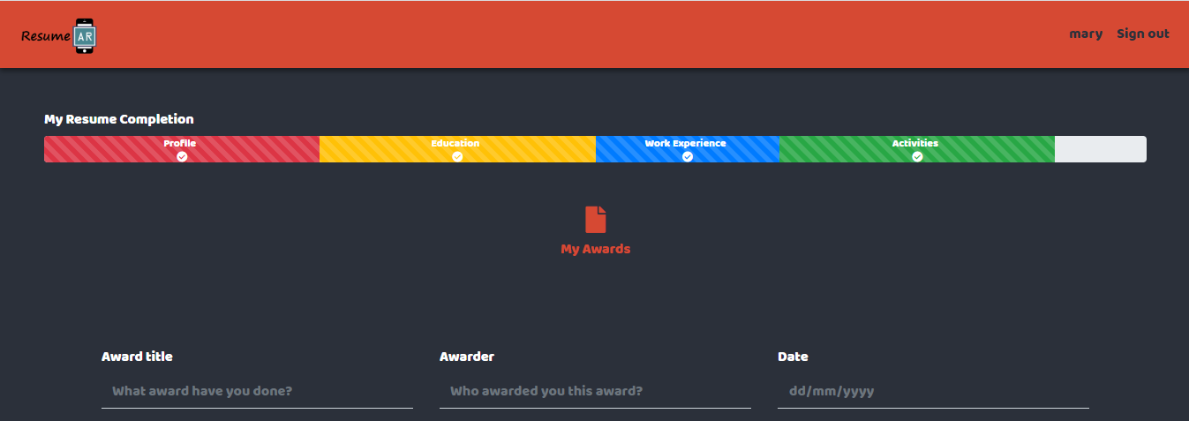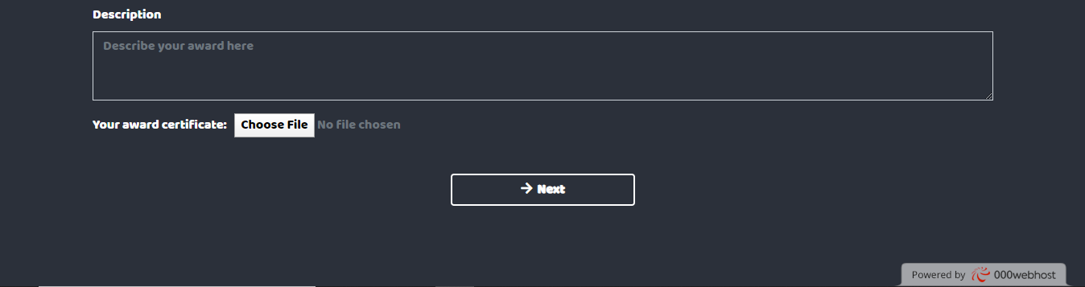

**Figure 5.8 Award section**

Figure 5.9 below shows the successful message of the resume completion. Users click on the Finish button to redirect them to the main dashboard. In the progress bar, the yellow bar shows that the award section has completed.

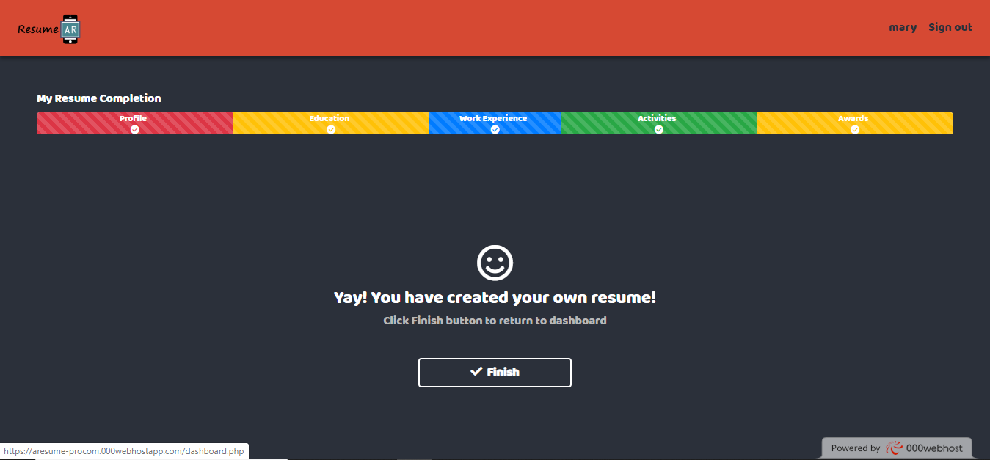

**Figure 5.9 Resume completion success message**

Figure 5.10 below shows an online resume with generated URL. When a resume is generated, a URL or link is generated for the particular resume. It is to allow users to share the URL of their resume and send it to the other people or hiring manager. In each resume, there is one QR code and a few AR markers. The QR code is embedded with AR scanner website URL which requires users to open the QR code scanner using their smartphone. Each AR marker on the resume stores different contents of different sections.

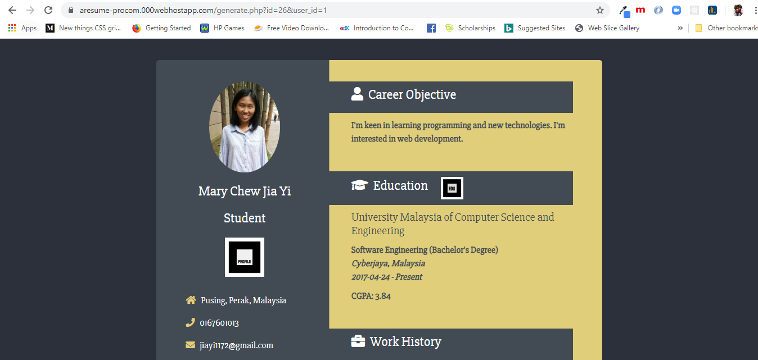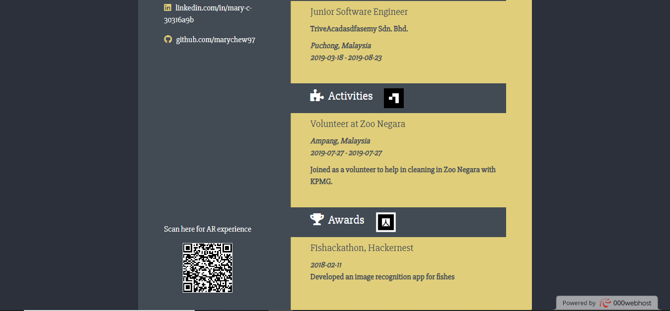

**Figure 5.10 Online resume with generated URL**

Figure 5.11 below shows where users can edit the resume. In the dashboard, users click the Edit button and it redirects them to the resume editing page. The new data input provided by the users will update the information in the database. Resume editing is applicable in all sections (personal information, education, work history, activities and awards).

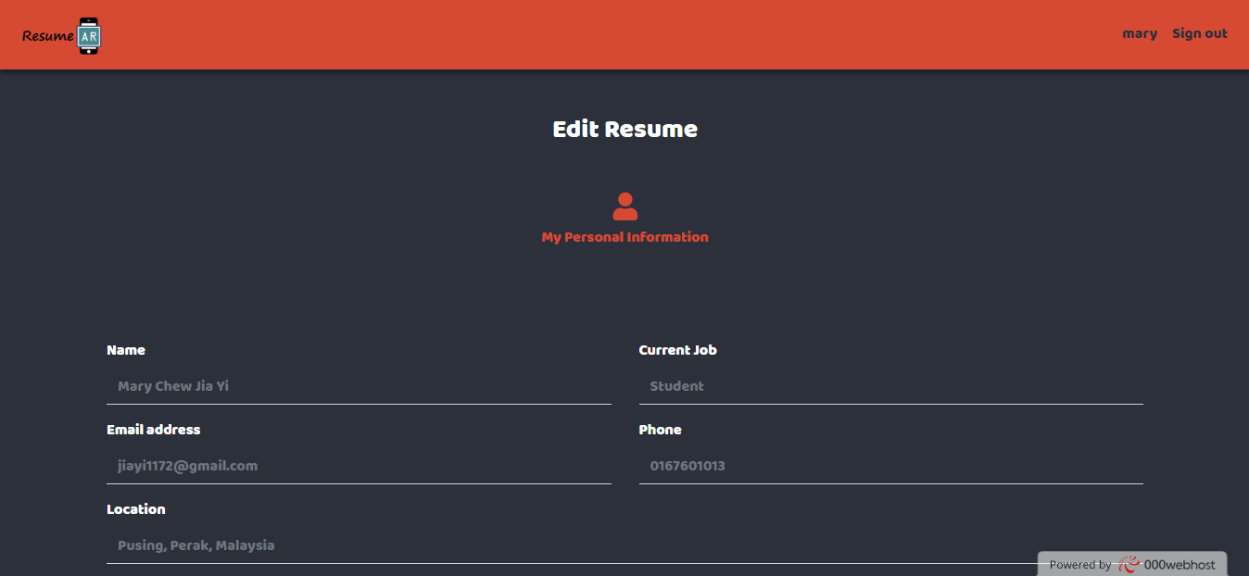

**Figure 5.11 Edit resume**

Figure 5.12 below shows where users can delete the resume. In the dashboard, users can click the Delete button and the delete confirmation message shows up. Users choose to delete it or cancel the deletion.

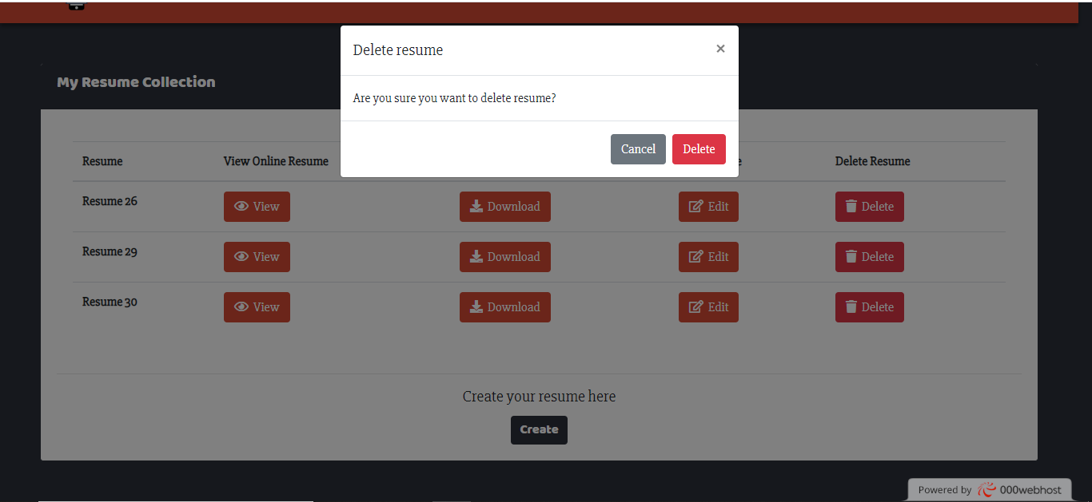

**Figure 5.12 Delete resume**

Figure 5.13 below shows PDF form of the resume. the resume PDF can be downloaded, printed as well as zoomed in and out.

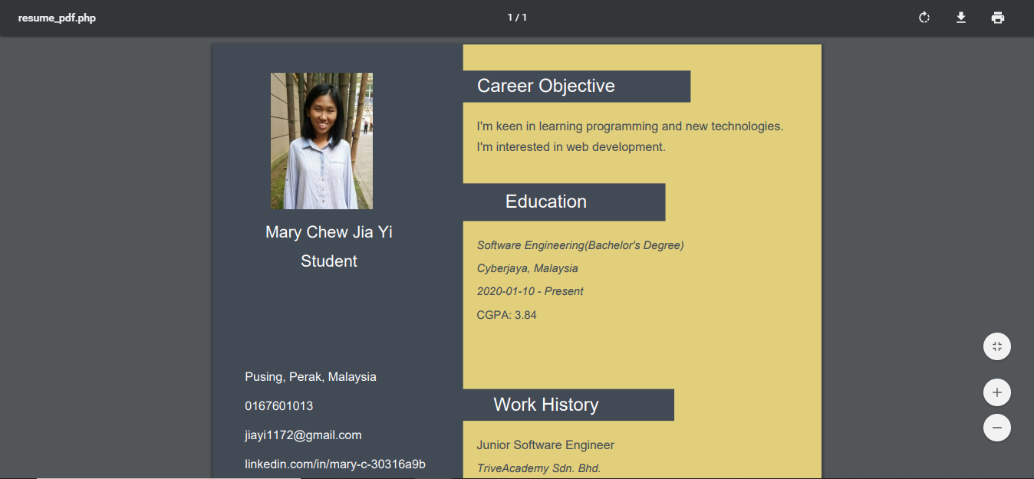

**Figure 5.13 Resume in PDF**

Figure 5.14 below shows the DOCX file of the resume. Click the Download button in the Resume (DOCX) column in the dashboard and users can save and download it. Users can view the resume in word processor like Microsoft Word and even edit the resume.

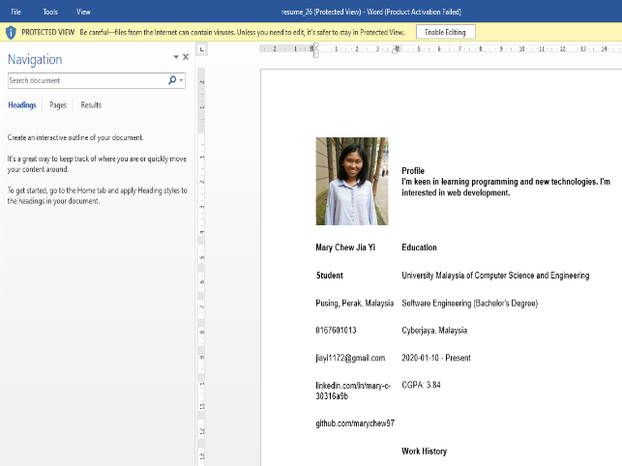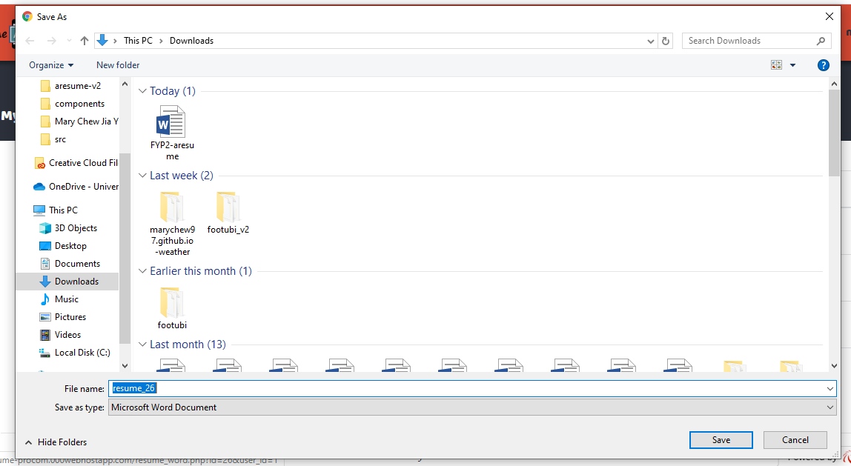

**Figure 5.14 Resume in Word**

Figure 5.15 below shows the scanning process to open the AR scanner URL. Find the QR code in the resume and open the QR code scanner of the smartphone to scan the QR code. It directs users to the AR scanner website and an instruction of how to scan the markers in the resume appears in an alert box. For the first-time users who scan the resume, users are prompted to allow the camera permission.

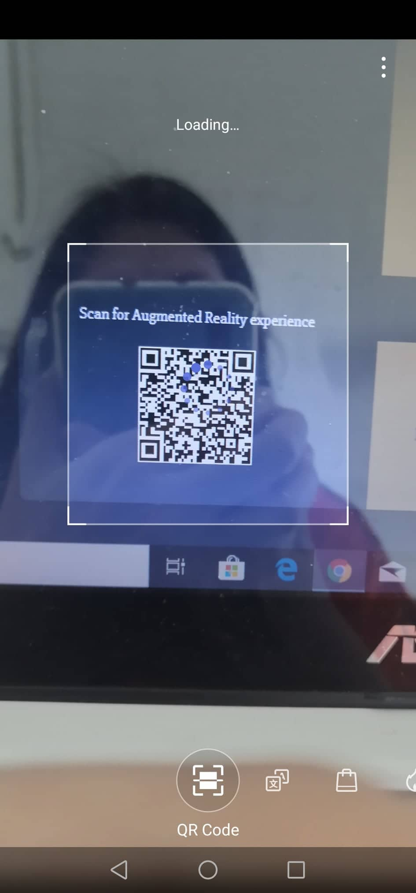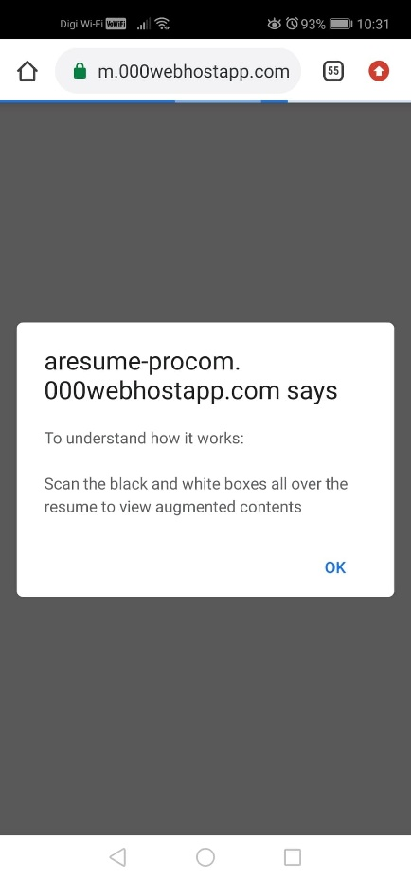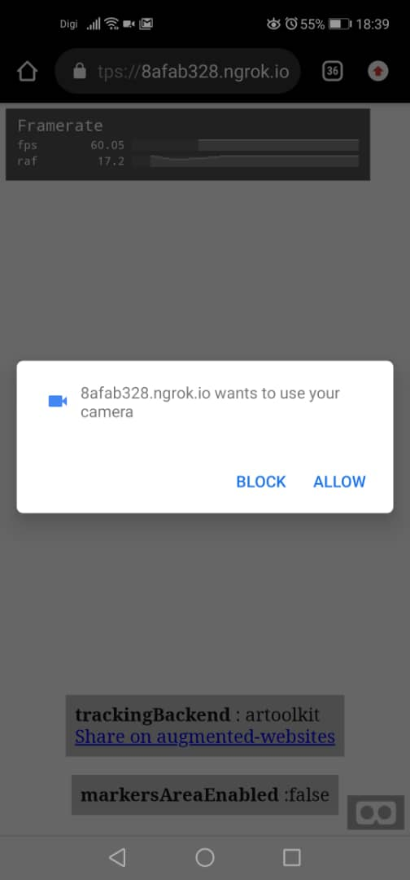

**Figure 5.15 The scanning process**

Figure 5.16 below shows the AR output display on the smartphone. When the AR scanner detects one of the markers, the AR content appears. When it is not detected, the content disappears.

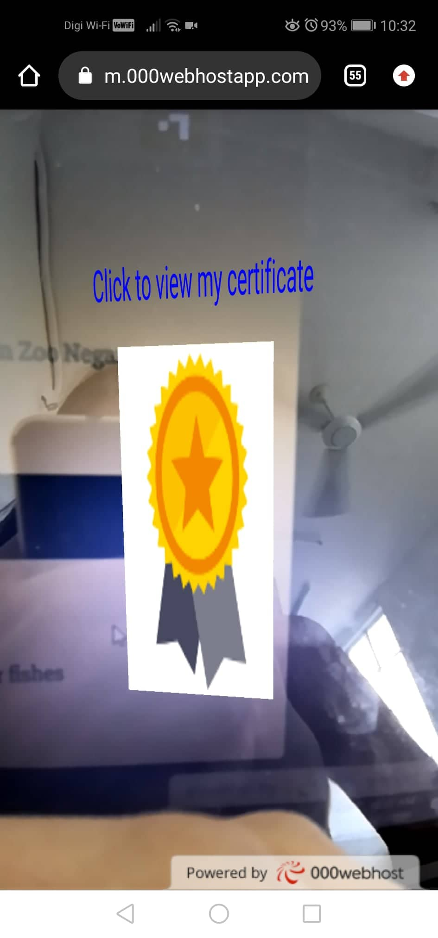

**Figure 5.16 The AR output display on smartphone**

### Libraries and Source Code

This section explains the libraries being used to implement this project and the source code of some main functions such as submitting information of a resume, viewing dashboard, generating resume in PDF, generating online resume with sharable URL, and scanning markers.

#### Libraries

Figure 5.17 and Figure 5.18 below show the libraries that have been used in this project. Such libraries are Bootstrap (front-end library), Google Fonts (library of great typographies through CSS), Font Awesome (font and icon toolkit), jQuery (JavaScript library), AR.js (lightweight library for web AR) and A-Frame (web framework for VR).

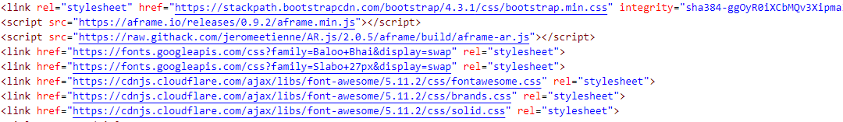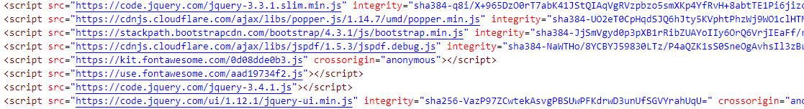

**Figure 5.17 Bootstrap, Google Fonts, Font Awesome, jQuery libraries**



**Figure 5.18 AR.js and A-Frame libraries**

#### Source Code

##### Create Resume

Figure 5.19 below shows the code snippet of submitting data and uploading video. It receives all the text input as well as the video file and insert them into the database. A file path to a folder is specified to store the video file when uploading the video. Figures 5.20, 5.21 and 5.22 show the code snippet of uploading transcript, activity photo and award certificate respectively.

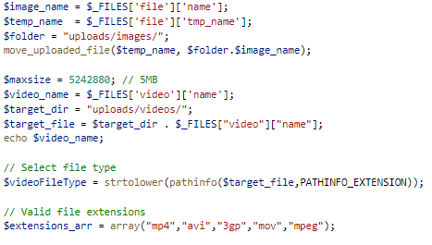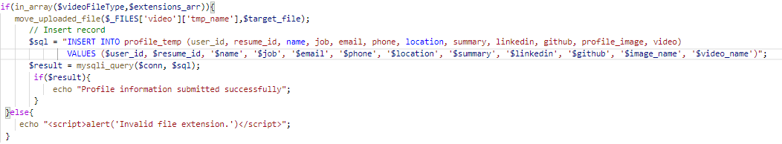

**Figure 5.19 Code snippet of submitting personal information**

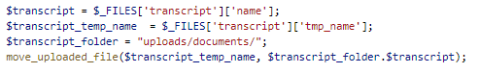

**Figure 5.20 Code snippet of uploading transcript**

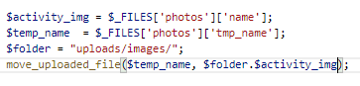

**Figure 5.21 Code snippet of uploading photo of an activity**

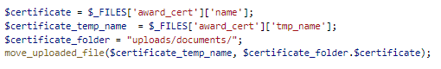

**Figure 5.22 Code snippet of uploading award certificate**

##### Viewing Dashboard

Figure 5.23 below shows the code snippet of the dashboard. All the resumes that have created by a user (specified with user_id) is listed in a table. If no resume is created, nothing to be shown in the table. Figure 5.24 below indicates each resume in the table is specified with its resume_id with user_id. In the table, there are four buttons namely View, Download, Edit and Delete respectively. View button is associated with link that embeds itself with resume_id and user_id which explains the generated sharable link. Each button that is associated with link is embedded with resume_id and user_id.

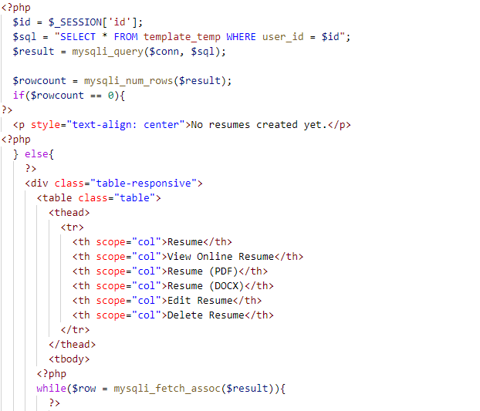

**Figure 5.23 Code snippet of the dashboard.**

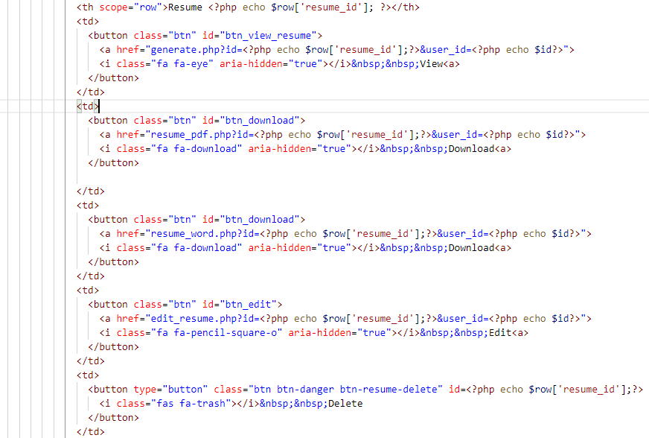

Figure 5.24 Code snippet of the particular resume

##### Scanning Resume

Figure 5.25 below shows the code snippet of directing users to the file downloading URL. The AR marker with the document content is triggered with click and is navigated to the file downloading URL.

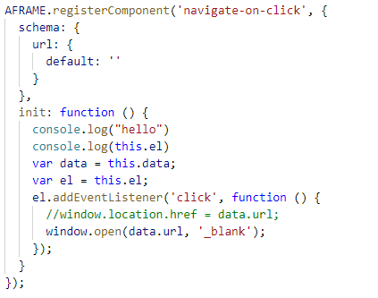

**Figure 5.25 Code snippet of navigating to another URL with click**

Figure 5.26 implies the code snippet of playing the video. The video plays when the marker is detected. When the marker is not detected, the video pauses and disappears but it appears and continues to play when the marker is detected again. This is handled by *this.toggle*.

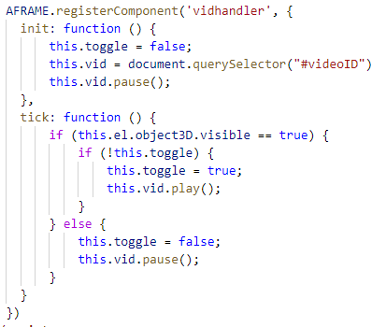

**Figure 5.26 Code snippet of playing the video**

Figure 5.27 below shows the code snippet of embedding video content in the marker. The video is obtained from the database of the particular resume (resume_id) and user (user_id) and is embedded in the custom marker file with .patt extension., which is pattern-profile_marker.patt. The video automatically replays and loops when it finishes playing.

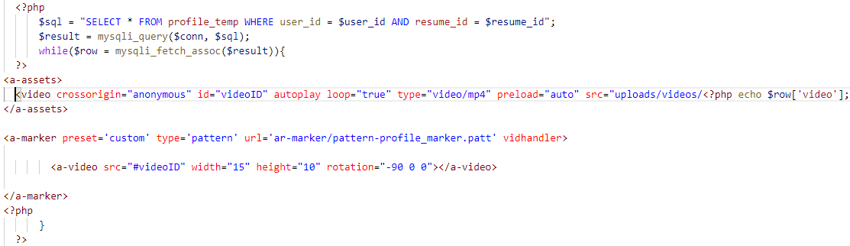

**Figure 5.27 Code snippet of embedding video content in the marker**

Figure 5.28 below shows the code snippet of embedding document content in the marker. The document is obtained from the database of the particular resume (resume_id) and user_id (user_id) and is embedded in the custom marker file named pattern-edu_marker.patt. The document icon shows up in the marker and requires users to trigger it by clicking it, which is shown by the *navigate-on-click* attribute. They will be directed to the file downloading URL.

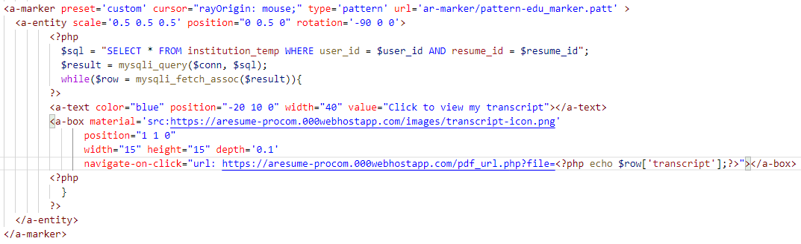

**Figure 5.28 Code snippet of embedding document content in the marker**

Figure 5.29 below shows the code snippet of embedding photo content in the marker. The photo is obtained from the database of the particular resume (resume_id) and user_id (user_id) and is embedded in the marker of barcode type. The photo appears when the marker is detected.

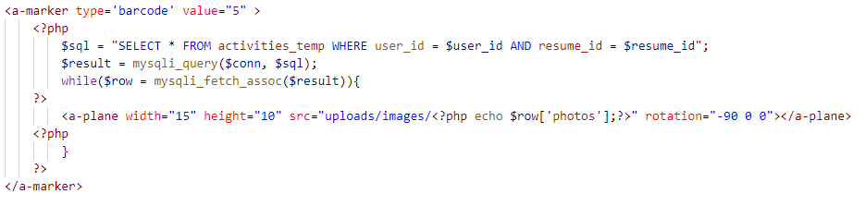

**Figure 5.29 Code snippet of embedding photo content in the marker**

### Testing

Testing is crucial in system development life cycle, in this case, Rapid Application Development. It is important to ensure if the system is defect free and check if the actual results match with the expected results. System testing and user acceptance testing (UAT) are used in this project.

#### System Testing

System testing is performed in this project to evaluate the compliance of the system with the user requirements. Table 5.1 and Table 5.2 below show the test cases of creating resume and scanning resume.

**Table 5.1 Test case of creating resume**

|  |  |
| --- | --- |
| Test Case Suite ID: | TCS001 |
| Test Priority | Medium |
| Description: | To create resume |
| Pre-condition: | 1. Internet access 2. Successful sign up and sign in 3. Each input field in submitting information for resume is optional |
| Post-condition | Not applicable |

|  |  |  |  |  |
| --- | --- | --- | --- | --- |
| Test Case ID | Action | Expected Result | Actual Result | Status |
| TC001 | Complete input data in text for profile information, education, work history, activities and awards. | The text inputs are inserted into the database. | The input data is inserted into the database. | Pass |
| TC002 | Incomplete input data in text for profile information, education, work history, activities and awards. | The empty and non-empty text inputs are inserted into the database. | The empty and non-empty text inputs are inserted into the database. | Pass |
| TC003 | Upload video, photos and documents | The file inputs are inserted into the database. | The file inputs are inserted into the database. | Pass |
| TC004 | No uploads of video, photos and documents | No file inputs are inserted into the database. | No file inputs are inserted into the database. | Pass |

**Table 5.2 Test case of scanning resume**

|  |  |
| --- | --- |
| Test Case Suite ID: | TCS002 |
| Test Priority | High |
| Description: | To scan resume |
| Pre-condition: | 1. Internet access 2. QR code scanner in the smartphone |
| Post-condition | Not applicable |

|  |  |  |  |  |
| --- | --- | --- | --- | --- |
| Test Case ID | Action | Expected Result | Actual Result | Status |
| TC001 | Open the QR code scanner and scan the QR code in the resume. | The QR code directs users to the AR scanner website. | The QR code directs users to the AR scanner website. | Pass |
| TC002 | Scan marker with AR video content. | The video plays. | The video plays. | Pass |
| TC003 | Scan marker with AR photo content. | The photo shows up. | The photo shows up. | Pass |
| TC004 | Scan marker with document content. | The document is downloaded. | The document is downloaded. | Pass |

#### User Acceptance Testing

User acceptance testing (UAT) is the testing phase after system testing. It is performed by the end users to evaluate if the system can handle the tasks in real scenarios based on the user requirements.

##### UAT Scope

Table 5.3 below shows the UAT scope. It is to define the UAT scope of the test cases in this project. There are two types of scopes in UAT, which are in scope (features that are tested) and out of scope (features that are not tested).

**Table 5.3 UAT scope**

|  |  |
| --- | --- |
| UAT - In Scope | UAT - Out of scope |
| 1. Building resume 2. Scanning markers on the resume | 1. Internet connectivity 2. Different versions of operating system in each smartphone |

##### UAT Assumptions and Constraints

Table 5.4 below indicates the assumptions and constraints of the test. Those assumptions and constraints include timing, available resources and test documentation processes.

**Table 5.4 UAT assumptions and constraints**

|  |  |
| --- | --- |
| Test environment | 1. Hardware and software are provided. 2. The test cases are conducted by 4 Quality Assurance managers. 3. Anywhere with available Internet access (Wifi or mobile network) |
| Test documentation | UAT test cases are compiled in this project. |
| Error reporting | Errors, failures and other flaws are reported from software libraries and Chrome. They are then directly sent to the particular project. |

|  |  |
| --- | --- |
| Time frames | The test results must be provided by 3rd January 2020. |
| Resources | 1. Human resources: 4 testers 2. Provided hardware: Asus, Huawei Nova 4, Samsung Galaxy A30, Vivo V5, Google Pixel 3, iPhone SE 3. Tested operating systems: Windows 10, Android version 6, 9, 10, iOS 13.3 4. Tested browsers: Google Chrome, Safari |

##### UAT Risks

Table 5.5 below shows the potential UAT risks are important to be aware while planning, executing and analysing the UAT test cases.

**Table 5.5 UAT risks**

|  |  |  |  |
| --- | --- | --- | --- |
| Description | Probability  High|Medium|Low | Impact  High|Medium|Low | Mitigation |
| Not properly trained testers | Medium | Medium | Provide instructions in detail for the first-time users |
| Incomplete test environment due to time constraints | Medium | Medium | Require realistic time and resource planning |
| Error handling: Testers are not aware on how to report bugs | Low | High | Prepare the bug reporting solution which is easy-to-use for them. Communicate with them frequently. |
| UAT test failure | Low | High | Carry out system testing before UAT test |

##### UAT Entry Criteria

Table 5.6 below shows the UAT entry criteria which is important to ensure that the UAT is well conducted. The following main criteria is as below:

**Table 5.6 UAT entry criteria**

|  |  |
| --- | --- |
| ID | Criteria |
| 5.1 | The development of the project is fully completed. |
| 5.2 | System tests are completed. |
| 5.3 | No high or medium defects are reported. |
| 5.4 | All reported bugs should be fixed. |
| 5.5 | UAT test environment (hardware, software, Internet access) is ready. |
| 5.6 | Testers got briefed and ready to start testing. |
| 5.7 | UAT test plan is available. |

##### UAT Requirements-Based Test Cases

Table 5.7 below describes the actual test cases that have been conducted by UAT testers. Each test case is described with steps to perform the action and the expected results.

**Table 5.7 UAT requirements-based test cases**

|  |  |
| --- | --- |
| ID | Test Cases |
| UAT001 | Building resume:   1. Sign up and sign in to the system with user login credentials. 2. Click *Create* button. 3. Choose a template. 4. Provide input details and upload medias (video, photos and documents if any) for each section (profile information, education, work history, activities and award). 5. Click *Finish* and return to dashboard. 6. Expected result:    * The resume created is shown in the database.    * The resume is ready for view, download, edit and delete.    * The medias uploaded are embedded in the markers. |
| UAT002 | Scanning markers on the resume:   1. Open the QR code scanner in the smartphone. 2. Scan the QR code on the resume. 3. The QR code directs users to the AR scanner website. 4. Scan the markers that are all over the resume. 5. Expected result:    * AR contents show up.    * The video (if uploaded) plays.    * The photos (if uploaded) shows up.    * The documents (if uploaded) is downloaded and can be viewed. |

##### UAT Test Results

Table 5.8 below shows the test results after being carried out by UAT testers. The test results are compiled in the table. Each case is associated with status.

**Table 5.8 Test results**

|  |  |  |  |  |  |
| --- | --- | --- | --- | --- | --- |
| ID | Test Case | Status | Tested By | Hardware specification used | Browser used |
| UAT001 | Building resume | Pass | Ruth Chew | Asus | Google Chrome |
| UAT002 | Building resume | Pass | Joseph Tan | Windows 10 x64 | Google Chrome |
| UAT003 | Scanning markers on the resume | Pass | Edward D’Silva | iPhone SE (iOS 13.3) | Safari |
| UAT003 | Scanning markers on the resume | Pass | Abdul Matyn | Google Pixel 3 (Android 10) | Google Chrome |
| UAT004 | Scanning markers on the resume | Pass | Ruth Chew | Vivo V5 (Android 6) | Google Chrome |
| UAT005 | Scanning markers on the resume | Pass | Joseph Tan | Samsung Galaxy A30 (Android 9) | Google Chrome |

All the UAT testers had been asked about one question, which is the speed of loading the AR content. Majority of them scanned the markers and the AR contents show up within seconds. One of the testers, Edward D’Silva who is an iPhone user, mentioned that the speed of loading the AR content in his phone with iOS 13.3 was quite fast, which was less than a second, despite of using 4G network.

### Observations

Using AResume, a resume is successfully created with AR markers attached to the resume. When scanning the resume, the QR code is successfully scanned and directed to the AR scanner website. There are several markers on the resume. each marker contains different contents. The AR scanner is able to scan each marker and different content appears in each marker.

Despite of that, the size of the marker affects the AR output. The bigger the marker, the higher the possibility of the AR content to appear. Besides, the camera permission is blocked unknowingly in some smartphones, causing the users to not know how to enable the camera permission when they get the notice.

### Summary

This project was implemented and tested successfully. With libraries such as AR.js and A-Frame, AR feature is successfully implemented in this project. However, testing is a must in order to make sure this project works as expected. Hence, system testing and user acceptance testing are carried out. System testing was conducted first, followed by the user acceptance testing. Test results have shown that the test cases have passed. Four testers (3 students and 1 working adult) have contributed to assist in testing the system.

# 

## CONCLUSION AND RECOMMENDATION

### Conclusion

This project summarizes that a resume generator is built alongside with web AR feature. This project allows users which are job applicants to create a resume for job hunting easily. Besides, web AR is implemented in this project. They will be able to upload any digital medias such as videos, documents and pictures that act as augmented medias when they scan the markers on the resume. The markers are where all the augmented medias are placed. Without the need to install any mobile applications, they will have the chance to enrich their experience with AR by just scanning a QR code which directs them to the web browser and scan the resume. The development technologies have been identified to develop the application in both web development and augmented reality as well as the rough-sketched diagrams of this application for a clear understanding of how it works. System testing and user acceptance testing were carried out to ensure the quality of the application. The intention of this project is to lessen burdens of job applicants when creating a resume and to enrich the AR experiences for users, especially hiring managers who view it.

### Recommendation

To improve the current project of AResume, there are some features that can be implemented in this project in the future as well as by the future technologies. In the coming future, 5G is said to be the promising mobile network that can elevate the AR performance and the speed of the mobile network. With 5G, the AR contents will be loaded way faster and more instantaneous which will boost up the AR performance. Besides that, resume with markerless-based will be promoted in the future. It means that users will be able to scan the resume without the need to scan and focus of the markers. With markerless-based, the markers will not occupy the space in the resume.

Moreover, integration with existing platforms like LinkedIn and Github can be implemented in the future as well. Importing information from LinkedIn and Github (would be useful for developers and programmers) to showcase more about the user.

In the business perspective, AResume can be promoted as the middle platform between job applicants and hiring managers. Hiring managers will be provided a system platform that can look for the talented job applicants that can fulfil their job requirements and responsibilities. They can subscribe to AResume with some monthly subscription fees to filter out all the resumes applied by job applicants based on particular fields. For example, hiring managers can look for the job applicants they think are fit for their job role in Information Technology (IT) field. With some subscription fee, AResume will enable the listing of all resumes of each job applicant in IT field.

## REFERENCES

(2019). Retrieved from XR.+: https://xr.plus/

Anastasia. (2016, November 24). *Should You Use Resume Writing Services (Or Not)*. Retrieved from Cleverism: https://www.cleverism.com/use-resume-writing-services/

Bhatt, T. (2018, July 11). *The Fundamentals of Developing Augmented Reality for Web With AR.js*. Retrieved from DZone: https://dzone.com/articles/the-fundamentals-of-developing-augmented-reality-f

Bonsor, K., & Chandler, N. (2019). *How Augmented Reality Works*. Retrieved from howstuffworks: https://computer.howstuffworks.com/augmented-reality.htm

Branson, T. (2017, April 14). *The 5 Best Reasons To Choose MySQL - And Its 5 Biggest Challenges*. Retrieved from Dataconomy: https://dataconomy.com/2017/04/5-reasons-challenges-mysql/

Buj, M. (2019). *Resume Sections You Must Include in Your Resume*. Retrieved from LiveCareer: https://www.livecareer.com/resources/resumes/basics/resume-components

Chouhan, H. (2017, January 24). *6 Reasons to Choose the Bootstrap CSS Framework*. Retrieved from OSTraining: https://www.ostraining.com/blog/coding/bootstrap/

Copeland, A. (2019). *6 Resume Writing Tips to Write a Stand-out Resume*. Retrieved from LiveCareer: https://www.livecareer.com/resources/resumes/how-to/write/how-to-make-resumes-easier

*Create Your AR & AI Apps for Free*. (2018). Retrieved from youaugment: https://youaugment.com/

David. (2018, June 21). *Why Use PHP in 2019?* Retrieved from Thoughtful Code: https://www.thoughtfulcode.com/why-use-php/

Doyle, A. (2019, July 11). *Different Resume Types*. Retrieved from thebalancecareers: https://www.thebalancecareers.com/resume-types-chronological-functional-combination-2063235

Etienne, J. (2017, July 11). *Creating Augmented Reality with AR.js and A-Frame*. Retrieved from A-Frame: https://aframe.io/blog/arjs/

*Free Resume Creator Online*. (2019). Retrieved from Resumizer: https://resumizer.com/resume_creator.htm

Heathfield, S. M. (2018, August 8). *Learn Why a Resume Is Important for an Employer*. Retrieved from thebalancecareers: https://www.thebalancecareers.com/resume-and-why-is-it-important-1918246

Hein, R. (2012, July 25). *6 reasons you should be using jQuery*. Retrieved from Javaworld: https://www.javaworld.com/article/2078613/6-reasons-you-should-be-using-jquery.html

Huynh, C. (2019, April 04). *My first steps with the Web AR*. Retrieved from siclo: https://www.siclo-mobile.com/my-first-step-with-the-web-ar

*Introduction*. (2019). Retrieved from A-Frame: https://aframe.io/docs/0.9.0/introduction/

*Introduction to Node.js*. (2019). Retrieved from nodejs: https://nodejs.dev/

Jain, A. (2019). *Unified Modeling Language (UML) | Sequence Diagrams*. Retrieved from GeeksforGeeks: https://www.geeksforgeeks.org/unified-modeling-language-uml-sequence-diagrams/

Jayaram, P. (2016, November 30). *When to Use (and Not to Use) MongoDB*. Retrieved from DZone: https://dzone.com/articles/why-mongodb

Kurtuy, A. (2017, October 19). Retrieved from novoresume: https://novoresume.com/career-blog/using-a-resume-builder-advantages-and-disadvantages

Kurtuy, A. (2017, October 19). *Advantages & Disadvantages For Using a Resume Builder*. Retrieved from novoresume: https://novoresume.com/career-blog/using-a-resume-builder-advantages-and-disadvantages

Kurtuy, A. (2017, October 19). *Advantages & Disadvantages For Using a Resume Builder*. Retrieved from novoresume: https://novoresume.com/career-blog/using-a-resume-builder-advantages-and-disadvantages

Kurtuy, A. (2019, October 17). *CV vs. Resume - What are the Differences & Definitions [+ Examples]*. Retrieved from Novoresume: https://novoresume.com/career-blog/cv-vs-resume-what-is-the-difference

Mahmood, H. (2018, May 28). *Advantages of Developing Modern Web apps with React.js*. Retrieved from Medium: https://medium.com/@hamzamahmood/advantages-of-developing-modern-web-apps-with-react-js-8504c571db71

McGath, G. (2019, November 3). *000WebHost: Truly Free Web Hosting… But What’s The Downside? We Found Out*. Retrieved from WhoIsHostingThis?: https://www.whoishostingthis.com/hosting-reviews/000webhost/

Mustafa, Z. (2018, November 7). *Writing a resume: Art of your ownself*. Retrieved from New Straits Time: https://www.nst.com.my/education/2018/11/429011/writing-resume-art-your-ownself

Owens, P. (2014, January 23). *The 10 Key Components Of A Great Resume*. Retrieved from Work It Daily: https://www.workitdaily.com/resume-key-components-great

RAD. (2018, October 31). *Rapid Application Development: Changing How Developers Work*. Retrieved from kissflow: https://kissflow.com/rad/rapid-application-development/

*Resume*. (2019). Retrieved from Ginger: https://www.gingersoftware.com/content/writing-center/resume/

Roo, J. (2015, April 27). *The Importance of a Well Written Professional Resume | Roo Resumes*. Retrieved from LinkedIn: https://www.linkedin.com/pulse/importance-well-written-professional-resume-roo-resumes-judi-roo/

*SDLC - RAD Model*. (2019). Retrieved from tutorialspoint: https://www.tutorialspoint.com/sdlc/sdlc_rad_model

Segal, N. (2019). *10 Common Uses of Bootstrap*. Retrieved from HTMLGoodies: https://www.htmlgoodies.com/html5/markup/10-common-uses-of-bootstrap.html

Shahid. (2019, May 24). *Best Resume Builder – NovoResume Review*. Retrieved from codeforgeek: https://codeforgeek.com/best-resume-builder-novoresume/

*True Web AR*. (2018). Retrieved from 8thWall: https://www.8thwall.com/index.html

*Types of Resumes*. (2019). Retrieved from Minnesota State Careerwise: https://careerwise.minnstate.edu/jobs/resumecharts.html

Vogt, P. (2019). *The 10 worst resume mistakes to avoid*. Retrieved from Monster: https://www.monster.com/career-advice/article/avoid-the-top-10-resume-mistakes

*What is Augmented Reality (AR) and How does it work*. (2019). Retrieved from ThinkMobiles: https://thinkmobiles.com/blog/what-is-augmented-reality/

*What is AWS? Amazon Cloud Services Tutorial*. (n.d.). Retrieved from Guru99: https://www.guru99.com/what-is-aws.html

*What is mySQL and why do I need it?* (2019). Retrieved from 123Reg: https://www.123-reg.co.uk/support/servers/what-is-mysql-and-why-do-i-need-it/

*What is SnapCard ?* (2018). Retrieved from SnapCard: https://www.snapcard.id/en/

*What is the difference between 3G, 4G and 5G?* (2019, February 28). Retrieved from What Mobile: http://new.whatmobile.net/difference-3g-4g-5g/

*Why Are Resume Templates In MS Word BAD?* (2019, January 29). Retrieved from DoMyResume.NET: https://www.domyresume.net/single-post/2018/03/08/Should-You-Use-Resume-Templates-in-MS-Word

Qiao, X., Ren, P., Dustdar, S., Liu, L., Ma, H., & Chen, J. (2019). Web AR: A Promising Future for Mobile Augmented Reality-State of the Art, Challenges, and Insights. *Proceedings of the IEEE*, *107*(4), 651–666. https://doi.org/10.1109/JPROC.2019.2895105

Qiao, X., Ren, P., Dustdar, S., & Chen, J. (2018). A New Era for Web AR with Mobile Edge Computing. *IEEE Internet Computing*, *22*(4), 46–55. <https://doi.org/10.1109/MIC.2018.043051464>

Ferber, M., & Rauber, T. (2012). Mobile cloud computing in 3G cellular networks using pipelined tasks. *Lecture Notes in Computer Science (Including Subseries Lecture Notes in Artificial Intelligence and Lecture Notes in Bioinformatics)*, *7592 LNCS*, 192–199. https://doi.org/10.1007/978-3-642-33427-6_14

**APPENDICES**

APPENDIX A: AResume Survey

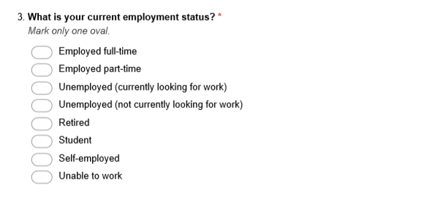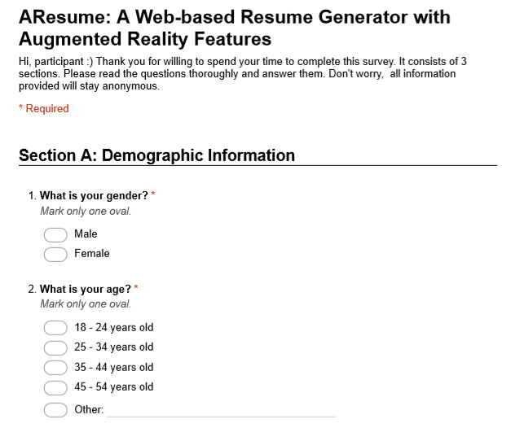

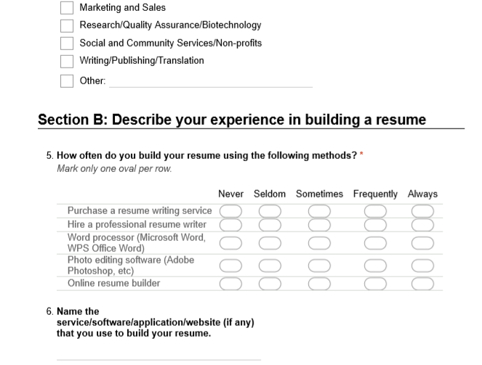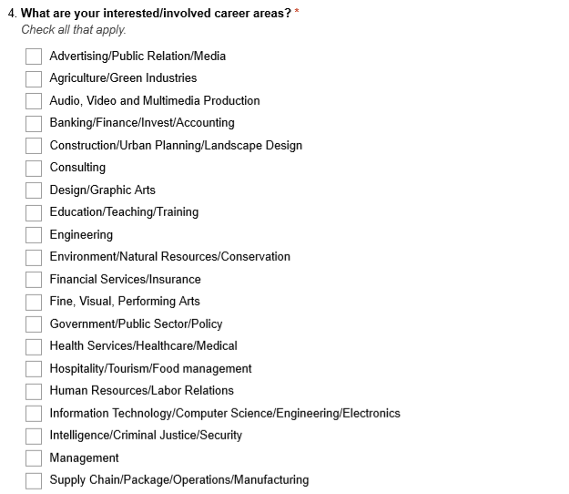

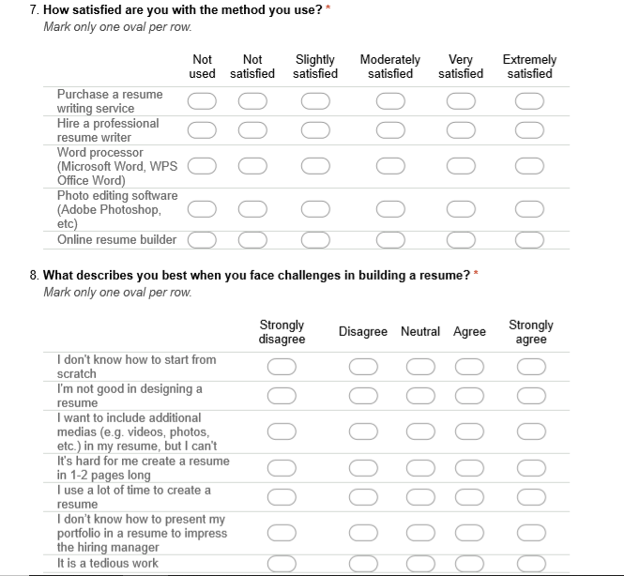

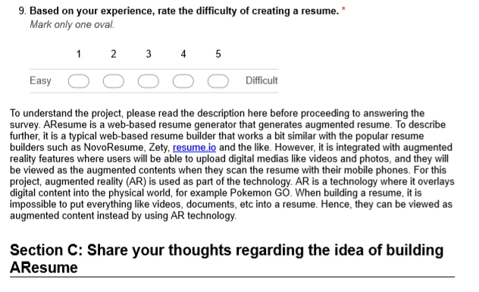

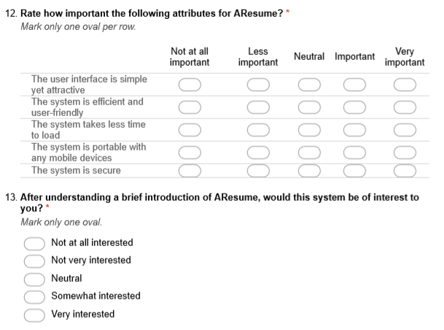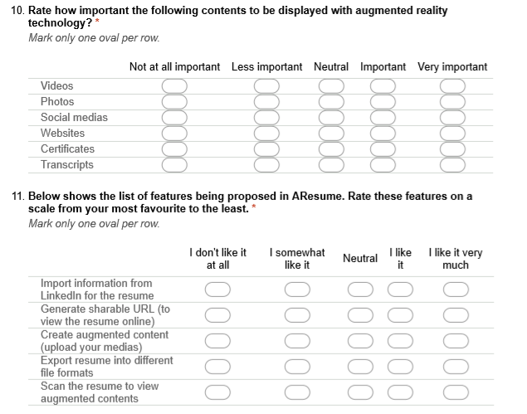

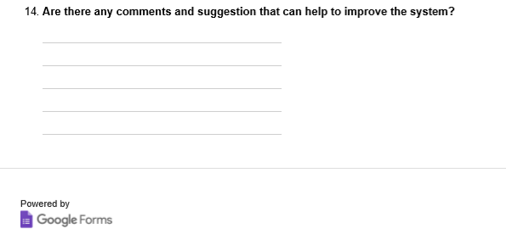

APPENDIX B: Gantt Chart for FYP 1

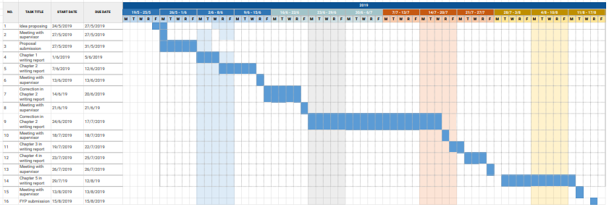

APPENDIX C: Gantt Chart for FYP 2

